“Blood Bank Management System”
A Project Report Submitted in the partial fulfillment of the requirements for the award of the degree of
BACHELOR OF TECHNOLOGY
In
DEPARTMENT OF COMPUTER SCIENCE ENGINNERING

ANUSHKA KULKARNI | : 2520030501
POOJITHA SAI | : 2520030103

Under the Esteemed Guidance of
Dr Neelima Gogineni Assistant Professor

Department of Computer Science and Engineering

K L (Deemed to be) University DEPARTMENT OF COMPUTER SCIENCE ENGINEERING



Declaration
The Project Report entitled “Blood Bank Management System” is a record of
Bonafide work of ANUSHKA KULKARNI- 2520030501, POOJITHA SAI
-2520030103 submitted in partial fulfillment for the award of B. Tech in Computer Science and Engineering to the K L University. The results embodied in this report have not been copied from any other departments/University/Institute.
ANUSHKA KULKARNI – 2520030501
POOJITHA SAI - 2520030103

K L (Deemed to be) University
DEPARTMENT OF COMPUTER SCIENCE ENGINEERING


CERTIFICATE
This is certify that the mini project based report entitled “Blood Bank Management System” is a bonafide work done and submitted by ANUSHKA KULKARNI - 2520030501, POOJITHA
SAI - 2520030103 in partial fulfillment of the requirements for the award of the degree of
BACHELOR OF TECHNOLOGY in Department of Computer Science Engineering, K L (Deemed to be University), during the academic year 2024-2025.
Signature of the Guide
Signature of the Course Coordinator Signature of the HOD

ACKNOWLEDGEMENT
The success in this project would not have been possible but for the timely help and guidance rendered by many people. Our wish to express my sincere thanks to all those who have assisted us in one way or the other for the completion of my project.
Our greatest appreciation to my Course Coordinator, Dr.Birru Srinivas, and my guideDr. Neelima Gogineni Department of Computer Science which cannot be expressed in words for his/her tremendous support, encouragement and guidance for this project.
We express our gratitude to Dr. P Venkateshwara Rao (CSE), Head of the Department for Computer Science Engineering for providing us with adequate facilities, ways and means by which we are able to complete this project-based Lab.
We thank all the members of teaching and non-teaching staff members, and also who have assisted me directly or indirectly for successful completion of this project. Finally, I sincerely thank my parents, friends and classmates for their kind help and cooperation during my work.
ANUSHKA KULKARNI – 2520030501
POOJITHA SAI – 2520030103

Abstract
The Blood Bank Management System is a web-based application designed to efficiently manage blood donation, inventory tracking, and donor–administrator interactions. The system allows donors to register, book donation appointments, and manage their profiles, while administrators can monitor blood stock, manage donor records, and handle blood requests from hospitals.
Unlike traditional systems that only store data, this project introduces intelligent features to improve donor safety and resource utilization. A live weather API is integrated to analyze environmental conditions and dynamically adjust donation slot availability, helping reduce health risks during extreme weather conditions.
The system also includes a smart blood expiry management module that identifies blood units nearing expiration and prioritizes their usage to minimize wastage. In addition, the application provides a blood compatibility matching system that helps quickly identify suitable blood types for patients, improving emergency response efficiency. A real-time dashboard is used to display blood availability, donation statistics, and expiring units for better decision-making.
Overall, the system enhances traditional blood bank operations by combining standard management features with intelligent scheduling and expiry optimization, Index thereby improving efficiency, donor safety, and effective utilization of blood resources.
S.  No. | Chapters | Topics | Page.no
 |  | Acknowledgement
 |  | Abstract
1 | Introduction | 1.1 Background of the project  1.2 Problem statement  1.3 Scope of the project  1.4 Objective(s)  1.5 Importance of the application  1.6 Target users/audience | 12-21
2 | System Requirements | 2.1 Hardware requirements  2.2 Software requirements  2.3 Development tools and Frameworks | 21-25
3 | Technology Stack | 3.1 Front-end (e.g., React.js, Angular, HTML/CSS)  3.2 Data Storage Design  3.3 Browser Local Storage System  3.4 API Integration  3.5 System Modules(e.g., User Authentication Module, Donor Management Module) | 25-34
4 | System Architecture | 4.1 High-level architecture diagram  4.2 Description of each layer (frontend, Application Logic Layer,Data Storage Layer) | 35-38
 |  | 4.3 Deployment architecture
5 | Design | ER Diagram / Database schema | 38
6 | Implementation | 6.1.1 Home Module  6.1.2 Authentication Module  6.1.3 Donor Module  6.1.4 Hospital Module  6.1.5 Blood Inventory Module  6.1.6 Appointment Module  6.1.7 Blood Compatibility Module  6.1.8 Weather Information Module  6.1.9 Admin Dashboard Module  6.2 Front-end logic (UI rendering, state management)  6.3 API integration  6.4 Authentication & Authorization | 39-44
7 | Features | 7.1 List of main features  7.2 How each feature works  7.2.1 User Registration and Login  7.2.2 Donor Management  7.2.3 Hospital Management  7.2.4 Blood Inventory Management  7.2.5 Blood Compatibility Checker  7.2.6 Appointment Booking  7.2.7 Blood Request Management  7.2.8 Weather Information  7.2.9 Admin Dashboard  7.2.10 Browser Local Storage  7.2.11 Responsive User Interface  7.2.12 Search and Filter Functionality  7.2.13 Error Handling and Input Validation | 45-50
8 | Testing | 8.1 Testing of Frontend and API Integration  8.2 Integration testing  8.3 Tools used for testing  8.4 Test cases and results | 51-55
9 | Deployment | 9.1 Steps to deploy  9.2 Environment configuration  9.3 Hosting of frontend | 56-59
10 | Challenges &  Limitations | 10.1 Issues faced during development  10.2 Solutions applied  10.3 Current limitations or known bugs | 59-63
11 | Future Enhancements | 11.1 Planned features  11.2 Possible integrations or optimizations | 64-67
12 | Conclusion | 12.1 Summary of the project  12.2 What was achieved  12.3 Skills learned during development | 68-72
13 | References | - tutorials, documentation sites used | 98-99

14 | Appendices | - Screenshots of the app  - Sample code snippets  - Installation/setup instructions  - User manual or guide  -Geo Tag photos with guide  -Review forms with guide signatures | 100-105

CHAPTER -1 INTRODUCTION

1.1 Background of the Project
In today’s healthcare sector, managing critical medical assets quickly and accurately can directly save lives. Among these resources, human blood is uniquely challenging because it cannot be artificially manufactured and carries a strict, highly volatile shelf life. Whole blood units expire within 35 to 42 days of collection, while specific vital sub-components, such as platelets, remain viable for only 5 days.
Historically, blood banks and regional medical centers relied on manual logs, paperwork, and physical phone chains to track availability and coordinate donations. Because these entities operated on independent, localized systems without a shared communications infrastructure, deep operational gaps occurred. A hospital could run into an emergency deficit of a specific blood group during an acute trauma influx, while a nearby community center held identical, unallocated units that were quietly moving toward expiration unnoticed.
Modern web technologies make it possible to completely solve these communication and visibility gaps directly inside a unified single-page application (SPA). This project—developed under the Full Engineering Design Framework (FEDF)—uses a modern frontend architecture to eliminate manual tracking errors and build a direct digital pipeline between voluntary public donors and hospital inventories. By shifting the coordination logic directly into a highly responsive browser interface, the system replaces logistical guesswork with instant, data-driven precision.
Key Foundational Pillars of the System:
- Dual-Role React (JSX) Architecture: Built completely within the React framework to handle two distinct user pathways—Donors and Hospitals. The application coordinates profiles, appointment calendars, and live stock metrics instantly on the client side using centralized react hooks (useState), completely eliminating slow server-rendering delays during critical emergency situations.
- Automated Biological Compatibility Matrix: Features a built-in cross-match solver module
(dashboard.jsx) that instantly maps out safe biological blood group give-and-receive permutations. This feature substitutes human clerical guesswork with system-enforced validation rules right on the dashboard.
- Lightweight, Custom Layout Design: Replaces heavy external UI frameworks with native CSS Grid and Flexbox layout structures (App.css, index.css). This maintains a small, fast-loading application bundle size while providing clean, high-contrast visual tokens—using clinical deep red (#c0202a) for donor environments and institutional blue (#1565c0) for administrative dashboards.

● Hardware-Integrated Proximity Engine: Connects directly to the browser's native HTML5
Geolocation API to capture active spatial coordinates (latitude and longitude) from the client device. This allows the application to capture donor positioning data instantly and map out nearby participants for emergency tracking.
- Proactive "Use-First" Dispatch Ledger: Equips hospital administrators with an inventory control table that actively monitors blood bag expiration profiles. The system dynamically isolates any unit with an active shelf life threshold of $\le 5\text{ days}$, moving it automatically to the very top of the priority list to prevent clinical waste.
- Ambient Weather Safety Interlocks: Integrates an environmental monitoring and simulation module within the application core. If simulated external ambient temperatures reach hazardous parameters ($\ge 38^\circ\text{C}$), the system triggers an automatic override that locks donor appointment grids, keeping community volunteers safe from traveling in extreme weather conditions.

1.2 Problem Statement
Despite continuous advancements in digital healthcare networks, modern blood banking systems still suffer from significant operational inefficiencies. Many regional medical centers and community blood banks continue to rely heavily on fragmented manual registers, physical spreadsheets, and reactive phone calls to track available supplies and coordinate emergency blood drives. Because these organizations operate on independent, localized systems without a shared communication infrastructure, critical logistical breakdowns frequently occur when speed matters most.
The core issues affecting existing blood banking methodologies are detailed below:

1. Missing Real-Time Stock Visibility
Hospitals and emergency clinics have no centralized, live view of total unit counts broken down by specific blood group phenotypes across their region. This information gap leads to a high frequency of supply imbalances. A hospital may unknowingly face a severe local deficit of a critical blood type during an emergency trauma influx, while an adjacent regional medical facility holds excess, unallocated units of that exact group without a method to flag the surplus.

2. Slower Emergency Donor Mobilization
When a specific or rare blood group is urgently needed, administrative operators must manually search through historical files or spreadsheet logs to find matching donor profiles. Once located, coordination is conducted through slow, human-dependent communication loops, such as calling individual volunteers one by one. This manual process introduces severe delays at a time when delivery speeds directly dictate patient survival rates.

3. Resource Waste from Expired Units
Human blood is an organic resource with a strict, limited shelf life; whole blood bags expire within 35 to 42 days of extraction, while vital components like platelets remain stable for only 5 days. Traditional inventory tracking methods lack proactive visual alerting to highlight older stock. Without automated prioritization, older, viable blood bags can sit unnoticed at the back of a refrigerator array while newer donations are used first, leading to unnecessary medical waste.

4. Absence of Spatial Context and Environmental Interlocks
Conventional software systems capture basic text-based addresses but fail to parse hardware geolocation data to quickly map out nearby participants for immediate emergency tracking. Furthermore, scheduling systems operate completely separate from shifting environmental variables. For example, during dangerous heatwaves or extreme blizzards, traditional booking sites continue to accept appointments automatically. They do not implement safety overrides to lock scheduling grids and protect donors from traveling during hazardous weather.
Core Operational Inefficiencies:
- Fragmented Administration: Blood banks operate as separate data silos, forcing hospital staff to switch between manual registries and multi-channel phone chains during a supply crisis.
- Clerical Selection Risks: Checking biological donor-to-recipient compatibility by hand introduces avoidable human errors into critical cross-match verification pipelines.
- Passive Inventory Monitoring: Traditional stock sheets lack automated priority sorting, leading to critical medicine expiring on the shelf.
- Blind Emergency Tracking: Nearby public donors cannot be filtered instantly based on active positioning data, slowing down target response times.
- Unprotected Scheduling Channels: Systems fail to monitor simulated ambient stressors, allowing users to book donation slots even when extreme external temperatures present safety risks.

1.3 Scope of the Project
The scope of this project encompasses the design, functional boundaries, and technical features developed for the Blood Bank Management System (BBMS) prototype under the Full Engineering Design Framework (FEDF). Designed as a highly interactive, client-side application, the project delivers a complete web-based proof-of-concept centered around two primary user pathways—Donors and Hospitals. It focuses on optimizing front-end state management, automating biological tracking rules, and utilizing native browser hardware tools to streamline emergency blood logistics without unnecessary overhead.
The application contains specialized modules tailored to each role. On the onboarding front, the system handles functional registration and login form validations that verify input structures before routing users to their proper workspaces. Once authorized, hospital administrators gain access to an automated biological compatibility matrix and a live inventory management table. This inventory workspace dynamically monitors the remaining shelf life of each blood unit batch, instantly flagging units with a critical remaining lifespan of five days or less and moving them to the top of the interface to guarantee older, viable stock is used first. Concurrently, the donor interface provides scheduling grids that are linked directly to an ambient weather safety override module. This environmental safety mechanism monitors simulated external temperatures and triggers an automatic lock on appointment bookings if conditions reach or exceed 38°C, ensuring community volunteers are protected from traveling during extreme weather.
Geospatial awareness is handled natively through client hardware integration. The system connects directly to the browser's HTML5 Geolocation API to instantly capture active coordinates, such as latitude and longitude, from the client device. This geolocation capture allows the platform to track nearby participants for immediate emergency coordination. To keep the application lightweight and highly performant during a medical crisis, the layout engine is built entirely with native CSS Grid and Flexbox structural configurations. This design choice eliminates the need for heavy external third-party interface libraries while establishing sharp, high-contrast visual themes—utilizing clinical deep red for donor spaces and corporate deep blue for hospital dashboards.
To maintain an optimized prototyping phase, specific boundaries define what is excluded from the current version of the project. The system operates entirely within client-side memory states, meaning that refreshing the web browser flushes and resets active data structures back to their default initialization templates. Persistent backend SQL or NoSQL database connectivity is excluded from this development cycle. Additionally, while input fields run structural format verifications on the front end, the application does not communicate with production-grade cryptographic authentication servers, password hashing protocols, or multi-factor security token gateways. Finally, the platform manages alerts, reservation summaries, and urgent requests through instant dashboard updates rather than external communication carriers, and it tracks donor positions using raw hardware coordinates without rendering paid, third-party map visualizers.
Core Areas Included in the System Scope:
- Dual-Role Onboarding Pathways: Includes functional registration and login validation architectures configured to check input structures before routing users to their proper workspaces.
- Automated Clinical Tools: Embeds a biological cross-match matrix solver that automatically tracks safe give-and-receive rules across all major blood phenotypes directly on the active dashboard.
- Hardware Geolocation Capture: Integrates with the browser's native HTML5 Geolocation API to instantly pull active coordinates from the client device for localized donor tracking.
- Smart Safety and Stock Triggers: Deploys an inventory alert tracker that bubbles expiring units <= 5 days to the top of the admin panel, paired with a weather sensor override that locks booking grids if temperatures reach >= 38*Celsicus.

1.4 Objectives of the Project
The primary purpose of this project is to engineer an interactive, client-driven Blood Bank Management System (BBMS) prototype under the Full Engineering Design Framework (FEDF) that removes the operational friction separating voluntary public donors from hospital administrative networks. By shifting complex coordination logic, inventory tracking, and safety parameters directly into a reactive web browser interface, the system replaces manual paperwork with real-time, data-driven precision. This approach ensures that critical, highly perishable medical assets are tracked optimally and delivered to patients safely and efficiently.
The first phase of development focuses on building a functional dual-role workspace routing framework that manages entry paths for two distinct user categories. This involves implementing specialized registration and login interfaces equipped with client-side form validation mechanisms (BBLogin.jsx) to check email structures and field requirements. Once validated, the system uses state hooks (useState) to instantly route users to their role-specific dashboards—using a clinical deep red theme (#c0202a) to guide public donors and an institutional deep blue theme (#1565c0) for hospital administrators.
The second phase aims to completely eliminate human clerical errors and guesswork during emergency patient matching by automating clinical biological cross-matching logic. To achieve this, a static biological compatibility matrix is embedded directly within the central application code (dashboard.jsx). When a hospital operator selects or searches for a specific blood group, this internal look-up engine automatically evaluates biological give-and-receive permutations across all eight major blood phenotypes ($A+, A-, B+, B-, AB+, AB-, O+, O-$). This provides instant validation and displays exactly which donor types are safe for transfusion on the fly.
The third phase centers on integrating hardware-based geospatial positioning capture to establish real-time spatial awareness without the performance overhead or cost of heavy, external third-party mapping visualizers. The application connects directly to the browser's native HTML5 Geolocation API to capture live hardware coordinates, specifically latitude and longitude, from the user's active device. By collecting this spatial data, the platform allows hospital administrators to instantly scan for and map out nearby participants, enabling rapid donor tracking and mobilization during critical local supply deficits.
The final phase focuses on deploying automated safeguards that manage inventory lifespan and volunteer safety simultaneously. For supply tracking, the system builds an inventory control panel that automatically evaluates the remaining shelf-life arrays of stored units, instantly highlighting batches with an active threshold of <=5 days and moving them to the top of the interface to prevent clinical waste. For donor protection, the system integrates a weather simulation engine that continuously tracks simulated external conditions, automatically triggering a safety lock that freezes all appointment booking grids if ambient temperatures reach a hazardous threshold of >=38 degree Celsius.
Through these distinct developmental steps, the project establishes a robust frontend architecture capable of scaling to meet production-level needs. By unifying tracking, allocation, safety checkpoints, and hardware sensory inputs into a seamless client runtime environment, the resulting architecture sets a new standard for modern emergency medical services software engineering.
To summarize, the major objectives of the project are as follows:
- To design and develop a unified blood management platform integrating donor registrations, scheduling calendars, and active hospital inventories.
- To build an intuitive onboarding gate featuring client-side form validation to verify input formats before routing users.
- To configure a responsive, role-based workspace router separating public donors from institutional hospital administrators.
- To automate clinical biological cross-matching logic directly within the application state to calculate safe give-and-receive rules instantly.
- To enable real-time tracking by connecting natively to the browser's HTML5 Geolocation API to capture live coordinates.
- To optimize application bundle size and frontend load times by utilizing native CSS Grid and Flexbox structural configurations.
- To implement an automated "use-first" inventory control table that prioritizes and bubbles older blood units to the top of the interface.
- To eliminate clinical resource waste by systematically flagging stored blood components with a remaining lifespan of ≤5 days.
- To deploy an environmental simulation engine that dynamically tracks shifting external ambient temperatures within the application core.
- To enforce a smart safety override that automatically locks donor appointment grids when simulated temperatures reach ≥38∘C.

1.5 Importance of the Application
The practical value of this system stems from its ability to address deep-rooted vulnerabilities in emergency medical logistics, fundamentally transforming how medical centers and community volunteers interact during critical supply shortages. Rather than serving as a passive data repository that merely records transactions after they occur, the system functions as an active coordinator that protects vital biological resources and optimizes workflow efficiency when time is short. This systemic transformation alters the landscape of regional health resource management, ensuring that communication lags, administrative blind spots, and uncoordinated distribution methods never become a bottleneck for emergency patient care. By modernizing the operational framework, the application establishes a proactive model where real-time tracking, environmental variables, and biological safety parameters work together harmoniously to save lives.
First, the application is vital for preserving scarce medical assets through intelligent asset tracking. Because human blood components cannot be synthetically engineered and decay rapidly, tracking their lifespan requires active surveillance. The platform addresses this vulnerability by automatically identifying and isolating units nearing their expiration limit. By shifting these critical units to the center of administrative attention, the platform dramatically reduces the likelihood of life-saving materials being wasted due to poor shelf-management visibility or hidden storage placement within traditional hospital blood banking structures. This automated shelf-life prioritization shifts the workflow from reactive distribution to a highly efficient "use-first" protocol, ensuring optimal utility of every single donation.
Second, the system introduces necessary protective layers to human-driven medical processes that are traditionally prone to errors. In high-pressure clinical environments, manual validation of donor-to-recipient safety charts under tight deadlines introduces a significant risk of accidental clerical slips. Substituting this manual verification with an instantaneous validation algorithm secures absolute accuracy during blood distributions, removing human stress from the calculation. Furthermore, the application respects the welfare of the public by linking community booking access to external environmental monitors. This integration proves that modern healthcare software can actively protect volunteer safety from harsh external conditions while maintaining robust collection pipelines.
Third, the application provides an optimized technical footprint designed specifically for crisis-level web environments. By avoiding heavy, commercial user interface frameworks and utilizing native browser features, the portal ensures exceptionally low load times and rapid interactive responses. This lightweight architectural design means that hospital coordinators working under compromised network conditions, experiencing power instabilities, or relying on older hardware can still access and operate the dashboard smoothly. Consequently, technical overhead and system performance lags never become a barrier to urgent patient care, rendering the application highly resilient in unpredictable emergency scenarios.
Fourth, the reliance on client-side computational state management marks an intentional departure from traditional centralized system dependencies. By processing and managing dense algorithmic matching matrices directly within the client runtime environment, the application drastically minimizes server-side round trips and database lag. This localized computing framework is highly valuable during severe network outrages or high-concurrency disaster events, where centralized cloud services might be unreachable or bottlenecked by sudden traffic surges. The system leverages the browser's raw processing power to maintain operational integrity, ensuring that data manipulation, layout adjustments, and life-critical compatibility cross-matching remain instant and unhindered.
Finally, this system bridges the gap between disparate data networks by centralizing the communication pipeline. By establishing a shared framework where hospital inventory levels, geographic proximity markers, and donor availabilities are displayed concurrently, it replaces chaotic phone chains with immediate clarity. This structural visibility allows regional medical networks to work as a unified team rather than a collection of isolated silos, drastically reducing the time required to locate and mobilize rare blood phenotypes during a sudden crisis or localized trauma influx. By giving operators instant access to actionable data, the application optimizes critical workflows when every second counts.
Through these combined breakthroughs, the platform presents a major structural improvement over fragmented traditional methods. It creates a highly resilient digital framework capable of uniting distinct health domains under a common logistical vision. This comprehensive technical coordination optimizes every link in the supply chain—from the moment a volunteer coordinates an appointment to the final utilization of a safe, compatible blood unit at a patient's bedside. Ultimately, this application demonstrates how intelligent frontend architecture can redefine public health logistics, making it more agile, data-driven, and centered around human safety.

To summarize, the importance of this application can be understood through the following key points:
    - To mitigate the loss of perishable clinical resources by dynamically exposing and prioritizing inventory items approaching their expiration threshold.
    - To safeguard clinical processing by substituting manual chart cross-referencing with a hardcoded biological evaluation matrix.
    - To protect community volunteers from health hazards by tracking environmental stressors and suspending operations during extreme conditions.
    - To maintain high-speed web performance on restrictive networks by eliminating heavy, bloated third-party interface dependencies.
    - To extract immediate spatial coordinates from user devices without forcing regional clinics to subscribe to costly commercial mapping packages.
    - To consolidate fragmented coordination channels into a single operational interface, removing the need for chaotic phone chains.
    - To increase community engagement by stripping away complex enrollment forms in favor of simplified, user-specific onboarding paths.
    - To offer a lightweight, client-focused framework that handles dense logical tasks directly in the browser without server-side lag.
    - To provide administrative users with an organized overview of live supply levels and incoming booking queues simultaneously.
    - To serve as a functional design blueprint under the FEDF framework for building lean, high-performance emergency medical software solutions.

In conclusion, the Blood Bank Management System (BBMS) addresses critical vulnerabilities in emergency medical logistics by replacing slow, fragmented manual registries with an automated, browser-driven coordination hub. By rendering real-time stock levels, donor availabilities, and administrative queues on a unified interface, the system concise the dangerous operational blind spots. Patient safety is systematically guaranteed through a hardcoded biological crossmatch lookup engine that eliminates clerical errors on the fly, while emergency response times are greatly accelerated by leveraging native client geolocation features for localized donor tracking. Furthermore, the application enforces strict risk-mitigation protocols to simultaneously minimize perishable inventory waste and protect public volunteer health during extreme weather. Ultimately, the resulting client-side frontend architecture sets a highly resilient, cost-effective, and performance-driven software engineering blueprint tailored specifically for the rigorous demands of critical healthcare infrastructure.

1.6 Target Users / Audience
The functional architecture of the Blood Bank Management System (BBMS) is precision-engineered to address the specific workflows, technical constraints, and operational pain points of two primary active user groups, alongside regional healthcare oversight bodies. By establishing clear, role-specific boundaries and dedicated interface paradigms, the system ensures that distinct user groups interact with localized, relevant data modules without unnecessary cognitive overhead.

Primary Audience Segments:
- Voluntary Public Donors: This segment consists of civic-minded individuals seeking a streamlined, frictionless pathway to register their biological metrics, browse appointment grids, and contribute to local supply chains. These users benefit directly from the simplified onboarding validation paths, mobile-friendly responsive layout configurations, and localized safety interlocks that protect them from traveling during extreme weather conditions.
- Hospital Administrators and Lab Coordinators: This group comprises clinical professionals tasked with managing volatile blood bank stocks, running cross-match validations, and coordinating emergency resource mobilizations. The application provides these users with high-contrast dashboards featuring automated clinical compatibility matrices, hardware-driven geospatial tracking arrays, and proactive "use-first" inventory tables that bubble expiring units <=5days to the top of the workspace.
- Regional Healthcare Logistics Managers: This administrative tier focuses on systemic oversight, supply chain audit compliance, and resource distribution across multi-center medical networks under the Full Engineering Design Framework. They utilize the platform as a functional blueprint to analyze real-time demand patterns, coordinate bulk emergency transfers between silos, and evaluate the efficacy of localized, low-bandwidth software implementations during regional crises.
To summarize, the primary objectives for serving these target audiences are as follows:
- To streamline registration pipelines for voluntary public donors using client-side data validation models.
- To equip hospital administrators with real-time inventory dashboards that automatically surface short-lifespan blood units <=5days.
- To eliminate clinical matching errors through an embedded, error-free biological compatibility matrix solver.
- To grant emergency logistics managers immediate spatial awareness using native hardware geolocation tracking coordinates.
- To maximize platform accessibility across low-bandwidth regional medical networks by utilizing a lightweight, framework-free front-end infrastructure.

CHAPTER -2 SYSTEM REQUIREMENTS

2.1 Hardware Requirements
Hardware requirements define the physical components needed for the successful development, testing, and execution of the Blood Bank Management System. Since the application is a web-based system developed using React.js and Browser Local Storage, it does not require high-end computing resources or specialized hardware. The project is lightweight, making it accessible to both developers and end users using standard computing devices. However, a stable and reliable hardware environment is essential to ensure smooth development, testing, and deployment of the application.
During the development phase, the developers require a computer with a minimum Intel Core i3 processor or an equivalent AMD processor. For improved performance and multitasking, an Intel Core i5 or AMD Ryzen 5 processor is recommended. A system with at least 8 GB RAM is sufficient for running Visual Studio Code, React development tools, multiple browser tabs, and other supporting software simultaneously. Although the application itself is lightweight, additional memory improves responsiveness when debugging, testing, and building the project. A minimum of 256 GB SSD storage is recommended because solid-state drives provide faster read and write speeds, reducing application loading time and improving overall productivity. An active internet connection with a minimum speed of 10 Mbps is also required for downloading project dependencies, accessing documentation, using GitHub repositories, and integrating external services such as the OpenWeather API.
The development system should include a modern display with a minimum resolution of 1366 × 768 pixels, while a Full HD (1920 × 1080) monitor is preferred for designing responsive user interfaces and efficiently managing multiple development windows. Standard peripherals such as a keyboard and mouse are required for coding and testing purposes. Since the project does not involve graphics-intensive processing, integrated graphics available in modern processors are adequate for its development and execution.
From the end user's perspective, the hardware requirements are minimal because the Blood Bank Management System is accessed through a web browser. Users can access the application using a desktop computer, laptop, tablet, or smartphone with a dual-core processor or higher and at least 4 GB RAM. The application has been designed to be responsive and lightweight, allowing it to function efficiently even on entry-level devices. Since the project stores data using the browser's Local Storage, no additional storage hardware or dedicated database server is required. The browser automatically manages the storage of user information, appointment details, and inventory records within the local device, ensuring quick data retrieval and smooth application performance.
A stable internet connection is necessary for loading the application and accessing external services such as the weather information provided through the OpenWeather API. However, most application data is stored locally within the browser, reducing dependence on continuous internet connectivity for day-to-day operations. This approach makes the system suitable for educational purposes, prototype demonstrations, and small-scale organizational use without requiring expensive server infrastructure.
Overall, the hardware requirements for the Blood Bank Management System are simple, cost-effective, and easily achievable. The project is designed to run efficiently on commonly available computing devices while providing a smooth user experience. By utilizing browser Local Storage instead of a dedicated database server, the system minimizes hardware dependency, making it an economical and practical solution for demonstrating modern web application development concepts.

2.2 Software Requirements
Software requirements define the programs, operating systems, frameworks, and development tools required to design, develop, test, and execute the Blood Bank Management System. As the application is developed using modern web technologies, it depends on a software environment that supports frontend development, browser-based execution, and local data storage. The project is designed to run efficiently without requiring complex server-side software or database management systems, making it simple to develop and maintain.
The recommended operating system for development is Windows 10 or Windows 11, although the application can also be developed on Linux or macOS. Visual Studio Code (VS Code) is used as the primary Integrated Development Environment (IDE) because it provides syntax highlighting, debugging support, extension management, and an integrated terminal, making the development process efficient and organized. The user interface is built using React.js, a JavaScript library that enables the creation of reusable components and dynamic user interfaces. HTML5 is used to define the structure of the web pages, while CSS3 and Bootstrap are used to create a responsive and visually appealing design that adapts to different screen sizes.
The application's functionality is implemented using JavaScript (ES6), which provides features such as event handling, form validation, dynamic content updates, and interaction with Browser Local Storage. Instead of using a traditional database management system like MySQL or MongoDB, the project stores donor details, appointments, inventory records, and user preferences in the browser's Local Storage, allowing data to remain available even after the browser is refreshed or reopened. This approach simplifies development while providing persistent client-side storage for the application.
For testing and executing the application, a modern web browser such as Google Chrome, Microsoft Edge, or Mozilla Firefox is required because these browsers fully support React applications and Local Storage functionality. The project also integrates the OpenWeather API to retrieve real-time weather information, helping determine whether weather conditions are suitable for blood donation activities. An internet connection is necessary to access this external API and download project dependencies during development. Overall, the selected software technologies provide a reliable, lightweight, and efficient environment for developing and running the Blood Bank Management System while ensuring good performance, ease of maintenance, and a user-friendly experience

2.3 Development Tools and Frameworks
The development of the Blood Bank Management System requires a combination of modern tools and frameworks that support efficient web application development, user-friendly interface design, and smooth application performance. These tools provide the necessary environment for designing, coding, testing, and maintaining the project. Since the application is developed as a client-side web application, the selected technologies focus on creating a responsive, interactive, and reliable user experience while simplifying the development process.
The primary development environment used for this project is Visual Studio Code (VS Code). It is a lightweight and powerful source code editor that offers features such as syntax highlighting, intelligent code completion, integrated terminal, debugging tools, and extension support. These features help developers write clean code, identify errors quickly, and improve overall productivity. VS Code also supports React development through various extensions, making it an ideal choice for building modern web applications.
The user interface of the application is developed using React.js, a popular JavaScript library for building dynamic and component-based user interfaces. React allows developers to create reusable components, making the application easier to maintain and extend. It efficiently updates only the modified parts of the webpage using the Virtual DOM, resulting in faster rendering and improved performance. The component-based architecture also enables better organization of the project, allowing different modules such as donor management, blood inventory, appointment booking, and hospital requests to be developed independently.
To provide the basic structure of the application, HTML5 is used. It defines the layout of web pages, forms, navigation menus, buttons, and other interface elements. HTML5 also improves accessibility and ensures compatibility across different web browsers. The visual appearance of the application is designed using CSS3, which provides styling, layout control, animations, and responsive design features. CSS3 enables the application to maintain a clean and professional appearance while adapting to different screen sizes.
For responsive design and faster interface development, Bootstrap is used. Bootstrap provides pre-designed components such as navigation bars, buttons, cards, forms, tables, alerts, and grid layouts. These reusable components reduce development time and ensure consistency throughout the application. The responsive grid system allows the Blood Bank Management System to function effectively on desktops, laptops, tablets, and mobile devices without requiring significant modifications.
The application logic is implemented using JavaScript (ES6), which enables dynamic content updates, event handling, form validation, and interaction with browser features. JavaScript manages user actions such as donor registration, appointment booking, inventory updates, compatibility checking, and weather information display. Modern ES6 features such as arrow functions, modules, template literals, and asynchronous programming improve code readability and simplify application development.
Instead of using a traditional database management system, the project utilizes Browser Local Storage for storing application data. Local Storage enables the browser to save donor information, blood inventory records, appointment details, and user preferences locally on the user's device. This approach eliminates the need for a separate database server during the development phase while ensuring that stored data remains available even after refreshing or reopening the browser. It is a simple and efficient solution for frontend-based prototype applications.
The Blood Bank Management System also integrates the OpenWeather API to retrieve real-time weather information. The weather data helps determine whether environmental conditions are suitable for conducting blood donation activities safely. This integration demonstrates the use of external web services and enhances the practical functionality of the application by providing users with useful environmental information.
For testing the application, modern web browsers such as Google Chrome, Mozilla Firefox, and Microsoft Edge are used. These browsers provide built-in developer tools for inspecting HTML elements, debugging JavaScript code, monitoring Local Storage, and evaluating application performance. The developer tools help identify and resolve errors efficiently during the testing process.
Overall, the selected development tools and frameworks provide a stable, efficient, and user-friendly environment for building the Blood Bank Management System. The combination of React.js, HTML5, CSS3, Bootstrap, JavaScript, Browser Local Storage, Visual Studio Code, and OpenWeather API enables the development of a responsive, maintainable, and feature-rich web application capable of meeting the project's objectives while providing a smooth user experience.

CHAPTER-3 TECHNOLOGY STACK

3.1 Front-End Design
The front-end of the Blood Bank Management System serves as the primary interface through which donors, hospitals, and administrators interact with the application. It is responsible for presenting information in a clear, interactive, and user-friendly manner while ensuring smooth navigation between different modules of the system. The front-end has been developed using React.js, HTML5, CSS3, Bootstrap, and JavaScript (ES6) to provide a modern, responsive, and efficient web application. The design focuses on simplicity, accessibility, and responsiveness so that users can easily access the system from desktops, laptops, tablets, and mobile devices without any difficulty.
The overall objective of the front-end design is to create an intuitive interface that allows users to perform various operations such as donor registration, appointment booking, blood inventory management, compatibility checking, weather monitoring, and hospital request management. The application follows a clean and organized layout where each module is accessible through a well-structured navigation system. The interface is designed to minimize user effort by providing simple forms, meaningful icons, informative alerts, and responsive dashboards. This improves user experience and reduces the possibility of errors while interacting with the application.
The structural foundation of the application is built using HTML5, which defines the layout and organization of the web pages. HTML5 provides semantic elements such as headers, navigation bars, sections, forms, buttons, tables, and footers, making the application well-structured and easier to maintain. The use of semantic HTML also improves accessibility and browser compatibility, ensuring that the application performs consistently across different platforms.
The visual appearance of the Blood Bank Management System is designed using CSS3. CSS3 is responsible for styling the application, including colors, typography, spacing, animations, transitions, and responsive layouts. Modern CSS features such as Flexbox, Grid Layout, media queries, and animations are utilized to create an attractive and professional interface. The application uses a consistent color scheme with properly aligned components, making it visually appealing while maintaining readability and usability. Responsive design techniques ensure that the interface automatically adjusts according to different screen sizes, providing a seamless experience on desktops, tablets, and smartphones.
To further improve responsiveness and reduce development time, Bootstrap is incorporated into the project. Bootstrap provides a collection of pre-designed components such as navigation bars, cards, buttons, tables, alerts, forms, modals, and responsive grid layouts. These reusable components ensure consistency throughout the application while allowing developers to build professional user interfaces efficiently. The Bootstrap grid system enables the website to adapt smoothly to different display resolutions, ensuring that users receive the same functionality regardless of the device they use.
The core functionality of the front-end is developed using React.js, a component-based JavaScript library for building dynamic web applications. React enables developers to divide the user interface into reusable components, such as the navigation bar, donor registration form, appointment booking page, inventory dashboard, compatibility checker, weather information panel, and admin dashboard. Each component manages its own functionality independently, improving code organization and simplifying maintenance. React's Virtual DOM technology enhances application performance by updating only the necessary parts of the webpage instead of reloading the entire page whenever changes occur. This results in faster rendering and a smoother user experience.
JavaScript (ES6) provides the logic and interactivity of the application. It handles user interactions, validates form inputs, processes button click events, performs calculations, and dynamically updates the user interface. JavaScript is responsible for operations such as donor registration, appointment scheduling, blood compatibility checking, inventory updates, weather information retrieval, and displaying notifications to users. Modern JavaScript features such as arrow functions, modules, promises, template literals, and asynchronous programming improve code readability and maintainability while enhancing application performance.
Unlike traditional web applications that rely on server-side databases, this project uses the browser's Local Storage to maintain application data. Local Storage enables the application to store donor details, appointment records, blood inventory information, and user preferences directly within the user's browser. React components interact with Local Storage using JavaScript functions to perform Create, Read, Update, and Delete (CRUD) operations. This approach eliminates the need for a dedicated backend database while ensuring that information remains available even after refreshing or reopening the browser.
The Blood Bank Management System also integrates the OpenWeather API within the front-end to display real-time weather information. Using JavaScript's Fetch API, weather data is retrieved and presented to users in a clear and organized format. This feature helps determine whether weather conditions are suitable for conducting blood donation activities, thereby improving donor safety and adding practical functionality to the application. Proper error handling mechanisms are implemented to display informative messages if the API service becomes unavailable or if network connectivity issues occur.
Special attention has been given to user experience and accessibility throughout the application. Forms include validation to prevent incorrect data entry, buttons are clearly labeled, and navigation menus are designed for easy access to different modules. Dashboard pages provide summarized information through cards and organized sections, allowing administrators and hospital staff to quickly monitor blood inventory, appointments, and donor information. The responsive design ensures that all features remain accessible and functional across multiple devices and screen sizes.
Overall, the front-end design of the Blood Bank Management System successfully combines modern web technologies to create a responsive, interactive, and user-friendly application. The integration of React.js, HTML5, CSS3, Bootstrap, JavaScript, Browser Local Storage, and the OpenWeather API provides a robust and efficient platform for managing blood donation activities. The modular architecture, responsive interface, and dynamic functionality ensure that the application is easy to maintain, scalable for future enhancements, and capable of delivering a smooth and reliable user experience.

3.2 Data Storage Design
The Data Storage Design of the Blood Bank Management System plays a vital role in managing and maintaining the information generated by different modules of the application. As the project is developed as a frontend-based web application using React.js, it does not rely on a traditional database management system such as MySQL or MongoDB. Instead, the application utilizes the browser's Local Storage to store and retrieve data. This approach provides a simple, efficient, and cost-effective solution for managing application data during development while demonstrating the complete functionality of the Blood Bank Management System.
Browser Local Storage is a web storage feature provided by modern browsers that allows applications to store data in the form of key-value pairs. The stored data remains available even after the browser is refreshed or restarted, making it suitable for applications that require persistent client-side storage. In this project, Local Storage is used to store donor information, hospital details, blood inventory records, appointment bookings, user login information, and other application data. Since all information is stored locally within the user's browser, the application performs data retrieval and updates quickly without requiring communication with an external database server.
The application stores data in JSON (JavaScript Object Notation) format. JavaScript objects are converted into JSON strings using the JSON.stringify() method before being saved in Local Storage. Whenever stored information is required, the data is retrieved using the localStorage.getItem() method and converted back into JavaScript objects using JSON.parse(). This process enables the application to efficiently manage structured data while maintaining compatibility with React components and JavaScript functions.
The Blood Bank Management System performs Create, Read, Update, and Delete (CRUD) operations using Browser Local Storage. Whenever a new donor registers, an appointment is booked, or blood inventory is updated, the corresponding information is added to Local Storage. Existing records can be viewed, modified, or deleted whenever required. These CRUD operations are handled using JavaScript functions within the React application, ensuring that all modules remain synchronized and display the latest available information to the user.
The application maintains separate Local Storage keys for different modules to improve organization and simplify data management. For example, donor details, appointment records, blood inventory information, and hospital requests are stored independently. This modular storage approach reduces data complexity and makes future maintenance easier. React components retrieve only the information required for their specific functionality, improving application performance and code readability.
One of the significant advantages of using Browser Local Storage is its ability to provide persistent client-side storage without requiring additional server infrastructure. Since the data is stored directly within the user's browser, the application can continue to display previously entered information even after the page is refreshed or the browser is reopened. This feature provides a smooth user experience during project demonstrations and simplifies the overall system architecture by eliminating database configuration and server maintenance.
To ensure data consistency, the application validates user input before storing it in Local Storage. Registration forms, appointment booking forms, inventory management pages, and hospital request forms include validation rules to prevent incomplete or incorrect information from being saved. React state management is used together with Local Storage to ensure that the user interface is automatically updated whenever changes occur. As a result, newly added or modified information becomes immediately visible throughout the application without requiring manual page reloads.
Although Browser Local Storage is suitable for educational projects and prototype applications, it has certain limitations. The storage capacity is limited compared to traditional databases, and the stored information exists only within the user's browser. If the browser cache or Local Storage is cleared, all saved application data is removed. Additionally, Local Storage is not designed for multi-user environments because the stored data cannot be shared across different devices or browsers. Therefore, this implementation is most appropriate for demonstrating application functionality rather than supporting large-scale real-world deployment.
The data storage design has been developed with future scalability in mind. Because the application's data handling logic is organized into reusable React components and JavaScript functions, Browser Local Storage can easily be replaced with a database such as MongoDB, MySQL, or Firebase in future versions. Such an upgrade would enable centralized data management, multi-user access, enhanced security, cloud synchronization, and improved scalability while requiring only minimal modifications to the frontend application.
Overall, the data storage design of the Blood Bank Management System provides a lightweight, reliable, and efficient mechanism for managing application data. By utilizing Browser Local Storage, JSON data structures, React state management, and JavaScript-based CRUD operations, the application successfully stores and retrieves information while maintaining good performance and ease of use. The chosen storage approach simplifies development, reduces infrastructure requirements, and effectively demonstrates the complete functionality of the Blood Bank Management System, making it suitable for academic projects and frontend application development.

3.3 Browser Local Storage System
The Blood Bank Management System uses Browser Local Storage as its primary data storage mechanism instead of a traditional database management system. Local Storage is a built-in feature provided by modern web browsers that enables web applications to store data directly on the user's device in the form of key-value pairs. Since the project is developed entirely using React.js without a backend server, Local Storage provides a simple and efficient solution for storing and retrieving application data while maintaining persistence across browser sessions.
The application stores important information such as donor registration details, hospital information, appointment bookings, blood inventory records, user login data, and application preferences in Browser Local Storage. Whenever a user enters new information or updates existing records, JavaScript functions convert the data into JSON format using the JSON.stringify() method before storing it. When the application requires the stored information, it retrieves the data using the localStorage.getItem() method and converts it back into JavaScript objects using JSON.parse(). This process enables efficient data management while ensuring compatibility with React components.
The Blood Bank Management System performs Create, Read, Update, and Delete (CRUD) operations using Local Storage. New records are created during donor registration or appointment booking, existing records can be viewed through the application interface, updates are reflected immediately in the dashboard, and unnecessary records can be removed whenever required. React state management is synchronized with Local Storage so that changes are instantly displayed throughout the application without requiring a page refresh.
To improve organization, different categories of information are stored under separate Local Storage keys. For example, donor information, appointment details, hospital requests, blood inventory records, and weather-related preferences are managed independently. This modular storage approach simplifies data retrieval, reduces complexity, and makes the application easier to maintain and extend.
One of the major advantages of Browser Local Storage is its simplicity. It does not require server installation, database configuration, or internet connectivity for storing application data. Information remains available even after the browser is closed and reopened, providing a smooth user experience during demonstrations and testing. However, Local Storage has certain limitations, including limited storage capacity, browser-specific data storage, and lack of multi-user synchronization. Therefore, it is suitable for prototype applications and academic projects but not for large-scale production systems.
In future versions of the Blood Bank Management System, Browser Local Storage can be replaced with cloud-based databases such as MongoDB, MySQL, or Firebase to support centralized storage, secure user authentication, real-time synchronization, and multi-user access. Because the application's data management logic is well organized, this transition can be achieved with minimal modifications to the frontend components.
Overall, Browser Local Storage provides a lightweight, reliable, and efficient data management solution for the Blood Bank Management System. It supports all essential CRUD operations, ensures persistent client-side storage, and allows the application to function smoothly without requiring a dedicated backend server or database management system.

3.4 API Integration
The Blood Bank Management System integrates the OpenWeather API to provide real-time weather information within the application. This external API enhances the functionality of the system by allowing users to view current weather conditions before scheduling or participating in blood donation activities. Weather plays an important role in ensuring donor safety and planning blood donation events, making API integration a valuable feature of the application. The integration demonstrates how modern web applications can communicate with external services to retrieve live data and improve user experience.
The OpenWeather API is a web-based service that provides current weather information, including temperature, humidity, atmospheric pressure, wind speed, weather conditions, and location-based forecasts. The application sends an HTTP request to the API whenever weather information is required. The API processes the request and returns the weather details in JSON (JavaScript Object Notation) format. The received data is then processed using JavaScript and displayed in a simple and user-friendly interface.
The API communication is implemented using JavaScript's Fetch API, which allows the React application to send asynchronous HTTP requests without reloading the webpage. When a user enters or selects a location, the application constructs the API request using the required endpoint and API key. Once the request is sent, the server responds with the latest weather information. React components receive this response, extract the necessary values, and update the user interface dynamically. This process ensures that users always receive the latest available weather data.
The weather information displayed by the application includes temperature, weather condition, humidity, wind speed, and location details. These values are presented in an organized layout that is easy to understand. Based on the weather conditions, users can determine whether it is appropriate to schedule or attend a blood donation appointment. By integrating live weather data, the application provides additional support for planning donation activities more effectively.
Proper error handling mechanisms have been implemented to improve the reliability of the API integration. If the internet connection is unavailable, the API server does not respond, or an invalid location is entered, the application displays appropriate error messages instead of crashing. These validation and exception-handling techniques improve user experience and ensure stable application performance even when external services are temporarily unavailable.
Since the weather information changes continuously, the application does not permanently store API responses in Browser Local Storage. Instead, fresh data is retrieved whenever the user requests weather information. This approach ensures that users always receive accurate and up-to-date environmental conditions while reducing unnecessary storage of temporary data.
The API integration follows a modular implementation where the weather-related functionality is separated from other application modules. This improves code readability, simplifies maintenance, and allows future integration of additional APIs without affecting existing components. If required, other external services such as Google Maps, SMS notification systems, email services, or hospital management APIs can be integrated using the same development approach.
Overall, the integration of the OpenWeather API significantly enhances the functionality of the Blood Bank Management System. It demonstrates the practical use of external web services in modern frontend applications while providing users with accurate real-time weather information. The use of the Fetch API, JSON data handling, React components, and proper error management ensures reliable communication between the application and the external service. This feature improves user convenience, increases the practical value of the project, and showcases the ability of the application to integrate with real-world APIs effectively.

3.5 System Modules
The Blood Bank Management System is designed using a modular architecture, where each module performs a specific function while working together to provide a complete and efficient blood bank management solution. This modular approach improves the organization, maintainability, and scalability of the application. Each module is responsible for handling a particular set of tasks such as donor registration, blood inventory management, appointment scheduling, and hospital request processing. The integration of these modules ensures smooth communication between different functionalities and provides users with a simple and user-friendly experience.
3.5.1 User Authentication Module
The User Authentication Module provides secure access to the application by allowing users to register and log in. It validates user information before granting access and ensures that only authorized users can use the system. User details are stored in Browser Local Storage, enabling users to access their accounts during future sessions without requiring repeated registration.
3.5.2 Donor Management Module
The Donor Management Module maintains complete information about blood donors, including personal details, blood group, contact information, age, and donation history. It allows donors to register, update their profiles, and view their previous donation records. This module helps maintain an organized database of eligible blood donors and simplifies donor management.
3.5.3 Blood Inventory Management Module
The Blood Inventory Management Module manages the availability of blood units for different blood groups. It allows administrators or hospital staff to add, update, and monitor blood stock levels. The module also tracks blood unit availability and helps ensure that sufficient blood is available for emergency situations.
3.5.4 Appointment Booking Module
The Appointment Booking Module enables donors to schedule blood donation appointments according to their convenience. Users can select available dates and time slots while administrators can monitor upcoming appointments. This module helps reduce overcrowding and ensures better planning of donation activities.
3.5.5 Blood Compatibility Checker Module
The Blood Compatibility Checker assists users in identifying compatible blood groups for both donation and transfusion. Based on the selected blood group, the module displays suitable donor and recipient blood groups according to standard blood compatibility rules. This feature minimizes errors and improves the accuracy of blood allocation.
3.5.6 Weather Monitoring Module
The Weather Monitoring Module integrates the OpenWeather API to display real-time weather conditions. It provides information such as temperature, humidity, weather conditions, and wind speed, helping users determine whether environmental conditions are suitable for blood donation activities. This feature enhances donor safety and demonstrates the integration of external APIs within the application.
3.5.7 Blood Expiry Management Module
The Blood Expiry Management Module monitors the expiry dates of stored blood units. It helps administrators identify blood units approaching their expiration date, reducing wastage and ensuring that blood is utilized efficiently. This module supports better inventory management and improves the overall reliability of the blood bank.
3.5.8 Hospital Request Management Module
The Hospital Request Management Module allows hospitals to request blood units according to patient requirements. Administrators can review requests, verify blood availability, and allocate compatible blood units. This module improves communication between hospitals and blood banks while reducing response time during emergencies.
3.5.9 Geo-location Donor Finder Module
The Geo-location Donor Finder Module helps identify nearby blood donors based on their location. It assists hospitals in quickly locating suitable donors during emergency situations. By reducing the time required to contact eligible donors, this module improves emergency response and increases the chances of timely blood availability.
3.5.10 Admin Dashboard Module
The Admin Dashboard Module provides administrators with a centralized interface for managing the entire application. It displays summary information such as the total number of donors, available blood units, appointments, hospital requests, and inventory status. The dashboard enables administrators to monitor system activities, update records, and make informed decisions efficiently.
Overall, the modular architecture of the Blood Bank Management System improves the efficiency, reliability, and maintainability of the application. Each module performs a specific responsibility while working together to provide a comprehensive solution for blood donation management. The modular design also makes the application easier to update, maintain, and extend with additional features in future versions.

CHAPTER -4 SYSTEM ARCHITECTURE

4.1 High-level architecture diagram
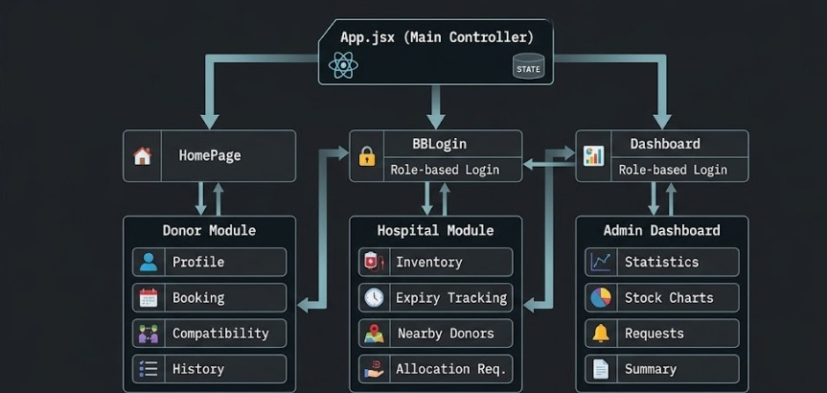

4.2 Description of Each Layer
The Blood Bank Management System follows a modular client-side architecture in which App.jsx acts as the main controller and coordinates the communication between different modules of the application. The architecture is divided into three logical layers: the Frontend Layer, the Application Logic Layer, and the Data Storage Layer. Each layer performs a specific responsibility while working together to provide a responsive and efficient blood bank management system.
Frontend Layer
The Frontend Layer provides the graphical user interface through which users interact with the application. As shown in the architecture diagram, the HomePage, BBLogin, and Dashboard serve as the main entry points to the system. The HomePage provides general information and navigation to the donor features. The BBLogin component performs role-based login for different users, while the Dashboard provides access to administrative functions. After successful login, users can access the Donor Module, Hospital Module, or Admin Dashboard according to their role. These modules are developed using React.js, HTML5, CSS3, Bootstrap, and JavaScript, providing a responsive and user-friendly interface across different devices.
Application Logic Layer
The Application Logic Layer manages all processing and decision-making within the application. In the architecture, App.jsx (Main Controller) acts as the central component that controls navigation, state management, and communication between all React components. It receives user requests from the frontend, processes the application logic, updates component states, and coordinates data flow between the Donor Module, Hospital Module, and Admin Dashboard. This layer also integrates with the OpenWeather API to retrieve real-time weather information used within the application. Since the project does not use a dedicated backend server, all business logic is executed on the client side using React.js and JavaScript.
Data Storage Layer
The Data Storage Layer manages all application data using the browser's Local Storage. Instead of storing information in a traditional database, the application saves donor profiles, appointment details, blood inventory records, login information, hospital requests, and other application data locally in the user's browser. React components interact with Local Storage using JavaScript methods such as setItem(), getItem(), removeItem(), and clear() to perform Create, Read, Update, and Delete (CRUD) operations. This approach ensures fast data access, persistence across browser sessions, and simplified application development without requiring a backend database.

4.3 Deployment Architecture (Cloud, Local, CI/CD Pipelines)
The Deployment Architecture of the Blood Bank Management System describes how the application is executed and made available to users. Since the project is developed entirely using React.js with Browser Local Storage, it follows a lightweight client-side deployment model. The application does not require a dedicated backend server or database server, making deployment simple and cost-effective. All application processing is performed within the user's web browser, while data is stored locally using Browser Local Storage.
During the development phase, the application is deployed and tested in a local development environment using Visual Studio Code and the React development server. The project is executed using Node Package Manager (npm), which starts the React application through the local development server. Users can access the application using a web browser by navigating to the local host address. This setup allows developers to test application features, identify errors, and make improvements before deployment.
The application is designed so that it can be easily deployed to static web hosting platforms such as GitHub Pages, Netlify, or Vercel. Since React generates static web files after the build process, the project can be hosted without requiring additional server-side infrastructure. Once deployed, users can access the application through a web browser from any device with an internet connection. Browser Local Storage continues to manage application data independently on each user's device.
Unlike traditional web applications, the Blood Bank Management System does not use a cloud database or backend server. Instead, all donor information, blood inventory, appointment records, and user data are stored locally within the browser. This architecture reduces deployment complexity and eliminates the need for database configuration, server maintenance, and cloud hosting costs. However, because the data is stored locally, it is available only on the device where it was created and cannot be synchronized across multiple users.
The current version of the project does not implement a Continuous Integration and Continuous Deployment (CI/CD) pipeline. Updates and modifications are manually tested and deployed by the developer. In future versions, CI/CD tools such as GitHub Actions, GitLab CI/CD, or Jenkins can be integrated to automate testing, building, and deployment processes. This would improve development efficiency, reduce deployment errors, and support continuous software updates.
Overall, the deployment architecture of the Blood Bank Management System is simple, lightweight, and suitable for academic projects. The client-side deployment approach, combined with Browser Local Storage, provides an efficient environment for demonstrating the application's features while allowing future migration to cloud-based hosting and automated deployment pipelines if required.

CHAPTER -5 DESIGN
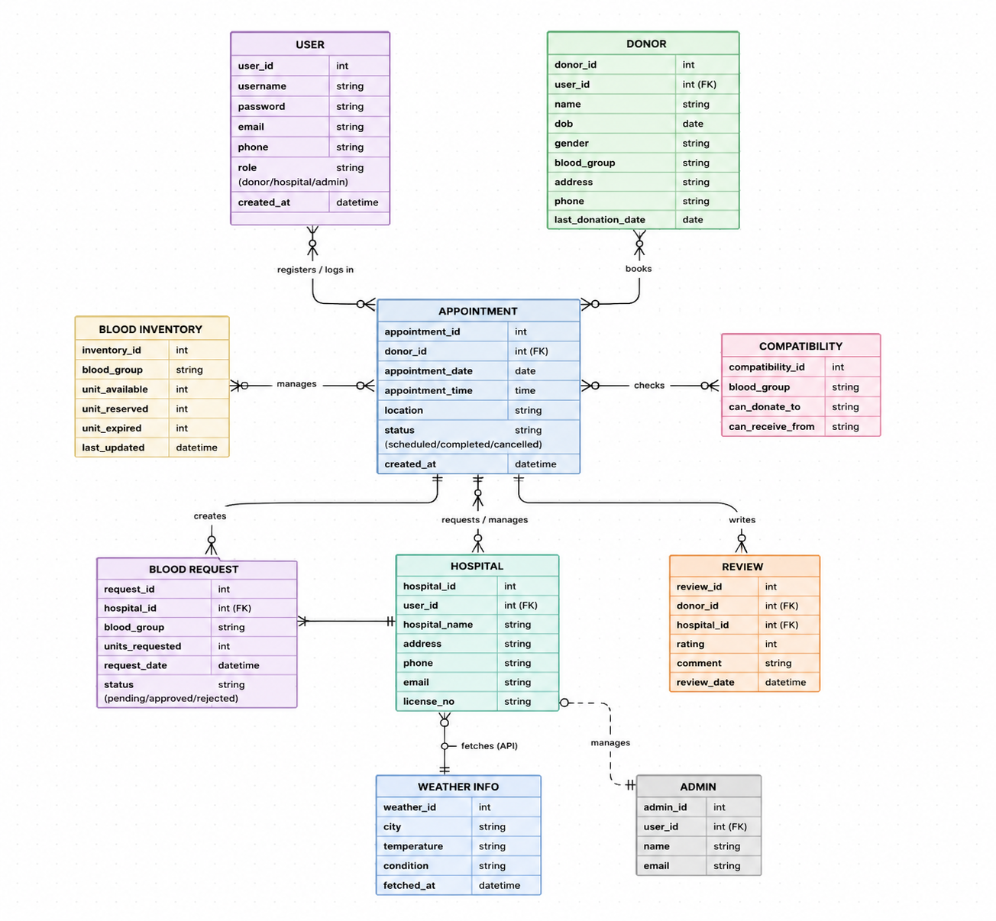

CHAPTER -6 IMPLEMENTATION

Section 6.1 – Module-Wise Implementation
The Blood Bank Management System is implemented using a modular architecture in which each module performs a specific function while interacting with other modules to provide a complete blood donation management solution. The application is developed using React.js, allowing each feature to be implemented as an independent reusable component. This modular approach improves code organization, maintainability, scalability, and simplifies future enhancements. The major modules of the system include the Home Module, Authentication Module, Donor Module, Hospital Module, Blood Inventory Module, Appointment Module, Blood Compatibility Module, Weather Module, and Admin Dashboard Module.
6.1.1 Home Module
The Home Module serves as the main entry point of the application and provides users with an overview of the Blood Bank Management System. It contains navigation links to different sections of the application, including donor registration, login, appointment booking, blood compatibility checking, and weather information. The module is designed with a responsive user interface that enables users to easily access all available services while maintaining a consistent user experience across different devices.
6.1.2 Authentication Module
The Authentication Module manages user registration and login functionality. Users create an account by providing their personal details, email address, password, and role. The application validates the entered information before storing it in Browser Local Storage. During login, the entered credentials are verified against the stored user records. Upon successful authentication, users are redirected to their respective dashboards according to their selected roles. This module ensures that only authorized users can access protected sections of the application.
6.1.3 Donor Module
The Donor Module allows blood donors to manage their personal information and donation activities. Users can register as blood donors by entering details such as name, age, gender, blood group, contact number, and address. Donors can update their profiles whenever necessary and schedule blood donation appointments. The module also provides access to previous donation records and compatibility information, making donor management simple and efficient.
6.1.4 Hospital Module
The Hospital Module enables hospitals to request blood units and monitor blood availability. Hospitals can submit blood requests based on the required blood group and quantity. The module allows hospital staff to verify inventory availability before placing requests, improving communication between hospitals and blood banks while reducing response time during emergency situations.
6.1.5 Blood Inventory Module
The Blood Inventory Module manages the available blood stock within the system. Administrators can add new blood units, update existing inventory records, monitor stock levels, and remove expired blood units. The inventory information is stored in Browser Local Storage and updated dynamically whenever modifications are made. This module helps maintain accurate records of available blood units for different blood groups.
6.1.6 Appointment Module
The Appointment Module provides donors with the ability to schedule blood donation appointments according to their preferred date and time. Appointment information is validated before being stored in Browser Local Storage. Users can view, modify, or cancel appointments whenever required. This module helps organize donation schedules and reduces overcrowding at blood donation centers.
6.1.7 Blood Compatibility Module
The Blood Compatibility Module determines compatible blood groups for donation and transfusion based on standard medical compatibility rules. Users simply select a blood group, and the application displays compatible donor and recipient blood groups. This module assists both donors and hospitals in identifying suitable blood matches quickly and accurately.
6.1.8 Weather Information Module
The Weather Information Module integrates the OpenWeather API to display current weather conditions. The application retrieves temperature, humidity, weather conditions, and wind speed using JavaScript's Fetch API. This information helps users determine whether environmental conditions are suitable for blood donation activities. The module demonstrates the integration of external web services within the React application.
6.1.9 Admin Dashboard Module
The Admin Dashboard Module provides administrators with complete control over the Blood Bank Management System. It displays summary information related to registered donors, blood inventory, appointments, hospital requests, and system statistics. Administrators can monitor all activities, update inventory records, manage user information, and oversee the overall functioning of the application through a centralized dashboard.
Overall, the module-wise implementation of the Blood Bank Management System follows a well-structured component-based architecture that ensures efficient interaction between different modules. Each module performs a dedicated responsibility while working together to deliver a reliable, responsive, and user-friendly application. The modular implementation also simplifies future development by allowing additional features and functionalities to be incorporated with minimal changes to the existing system.
.

Section 6.2 – Front-End Logic (UI Rendering and State Management)
The Blood Bank Management System is implemented using React.js, which follows a component-based architecture for building modern and interactive web applications. The front-end is responsible for rendering the user interface, managing user interactions, validating input, and updating the displayed information dynamically. The application is designed to provide a responsive and user-friendly experience while ensuring efficient performance across different devices and screen sizes.
The user interface is developed using HTML5, CSS3, Bootstrap, and React.js. HTML5 provides the structural elements of the web pages, CSS3 is used for styling and responsive layouts, and Bootstrap offers pre-designed components such as navigation bars, buttons, forms, tables, and cards. These technologies work together to create an attractive and consistent interface that allows users to navigate easily between different modules such as Home, Login, Donor Management, Hospital Management, Blood Inventory, Appointment Booking, Blood Compatibility Checker, Weather Information, and the Admin Dashboard.
React.js renders the user interface dynamically through reusable components. Each page or feature of the application is implemented as an independent component, allowing better code organization and easier maintenance. Components such as the Home Page, Login Page, Dashboard, Donor Module, Hospital Module, Inventory Module, Appointment Module, and Weather Module are loaded and updated independently. This modular architecture improves reusability and simplifies future enhancements.
The application uses React State Management to maintain and update data displayed on the user interface. React Hooks such as useState() are used to store dynamic data including user details, donor information, appointment records, blood inventory, weather information, and search results. Whenever a user performs an operation such as registering as a donor, booking an appointment, updating inventory, or checking blood compatibility, the corresponding state is updated automatically. React immediately re-renders only the affected components, providing a smooth user experience without refreshing the entire webpage.
The useEffect() hook is used to perform operations that occur when components are loaded or updated. It retrieves previously stored information from Browser Local Storage, loads application data during initialization, and fetches real-time weather information from the OpenWeather API. This ensures that users always view the latest available information whenever they access the application.
Navigation between different pages is managed using React Router, allowing users to move smoothly between modules without reloading the browser. Each route is associated with a specific React component, improving application performance and providing a seamless browsing experience. Protected pages such as the Admin Dashboard are displayed only after successful user authentication.
User interactions such as button clicks, form submissions, search operations, and menu selections are handled through JavaScript event handlers. Input validation is performed before processing user data to ensure that all required fields are completed correctly. Appropriate success and error messages are displayed to inform users about the status of their operations, improving usability and reducing the possibility of invalid data entry.
The application stores donor details, appointment records, blood inventory information, and user credentials in Browser Local Storage. React components communicate with Local Storage using JavaScript methods such as setItem(), getItem(), removeItem(), and clear(). The stored information is converted into JSON format before saving and converted back into JavaScript objects whenever it is retrieved. This mechanism enables persistent data storage while eliminating the need for a backend database.
Overall, the front-end logic of the Blood Bank Management System combines React.js, HTML5, CSS3, Bootstrap, JavaScript, Browser Local Storage, and React Hooks to provide a responsive, dynamic, and efficient user interface. The combination of component-based rendering, state management, event handling, and persistent local storage ensures smooth application performance, improved user experience, and simplified maintenance, making the system suitable for both academic demonstration and future development.

6.3 API Integration
The Blood Bank Management System integrates the OpenWeather API to provide users with real-time weather information. This integration enhances the functionality of the application by allowing users to view current weather conditions before scheduling or participating in blood donation activities. Since weather conditions can influence travel and outdoor events, displaying accurate weather information helps users plan their blood donation visits more effectively. The API integration demonstrates how external web services can be incorporated into a React-based application to improve the overall user experience.
The application communicates with the OpenWeather API using JavaScript's Fetch API, which enables asynchronous HTTP requests. When a user requests weather information, the application sends a request containing the required location and API key to the OpenWeather server. The server processes the request and returns the weather details in JSON (JavaScript Object Notation) format. The application then extracts important information such as temperature, humidity, weather conditions, wind speed, and city name before displaying it on the user interface.
The API communication is managed within React components using the useEffect() hook and asynchronous JavaScript functions. Whenever the weather component is loaded or a user searches for a different location, the application automatically sends a new request to the API and updates the displayed information. React's state management ensures that the latest weather details are rendered immediately without requiring the webpage to reload, resulting in a smooth and responsive user experience.
Proper input validation and exception handling are implemented to improve the reliability of the API integration. If the user enters an invalid city name, loses internet connectivity, or if the API service is temporarily unavailable, the application displays an appropriate error message instead of crashing. These validation techniques improve the stability and usability of the system while ensuring that users receive meaningful feedback during unexpected situations.
Unlike donor information and appointment records, weather data is not stored permanently in Browser Local Storage because it changes frequently. Instead, the application retrieves fresh weather information whenever the user requests it. This approach ensures that the displayed weather conditions are always accurate and up to date while reducing unnecessary storage of temporary data.
The API integration is implemented as an independent module within the React application, making it easy to maintain and extend. Additional external services such as Google Maps, SMS notifications, email services, or hospital management APIs can be integrated in the future using a similar approach without affecting the existing application architecture.
Overall, the integration of the OpenWeather API enhances the functionality and practicality of the Blood Bank Management System by providing accurate real-time weather information. The use of React.js, JavaScript Fetch API, JSON data handling, and proper error management ensures efficient communication with the external service while maintaining a responsive, reliable, and user-friendly application.

6.4 Authentication and Authorization
The Authentication and Authorization module of the Blood Bank Management System is responsible for providing secure access to the application and ensuring that users can access only the features relevant to their roles. Since the project is developed as a frontend-based application using React.js, authentication is implemented using Browser Local Storage without a dedicated backend server. This approach is suitable for academic projects and demonstrates the basic concepts of user authentication and access control.
The authentication process begins with user registration, where users provide essential information such as their name, email address, password, contact details, and role. Before storing the information, the application validates the input fields to ensure that all mandatory data is entered correctly. Once validation is successful, the user information is stored in Browser Local Storage in JSON format. This allows the application to retain user data even after the browser is refreshed or reopened.
During the login process, users enter their registered email address and password. The application retrieves the stored user information from Local Storage and compares it with the entered credentials. If the credentials match, the user is successfully authenticated and redirected to the appropriate dashboard. If the credentials are incorrect, the application displays an error message requesting the user to enter valid login details. This validation process helps prevent unauthorized access to the application.

The system implements role-based authorization to provide different levels of access for different users. After successful login, users are redirected according to their assigned role. Donors can register, manage their profiles, book appointments, check blood compatibility, and view weather information. Hospitals can submit blood requests, monitor blood availability, and manage hospital-related activities. Administrators have complete access to the system, including managing donor records, blood inventory, appointments, hospital requests, and overall system administration. This role-based approach improves system security and ensures that users access only the functionalities relevant to their responsibilities.
The application also manages user sessions using Browser Local Storage. Once a user logs in successfully, the login status and user role are stored locally. This allows the application to remember the user's session while navigating between different pages. During logout, the stored session information is removed from Local Storage, requiring users to log in again to access protected sections of the application.

Although the current authentication mechanism is implemented entirely on the client side, the system has been designed to support future integration with secure authentication technologies such as JSON Web Tokens (JWT), OAuth, Firebase Authentication, or backend-based authentication services. These technologies would provide stronger security, encrypted communication, centralized user management, and multi-device authentication for real-world deployment.

Overall, the Authentication and Authorization module provides a simple, reliable, and efficient mechanism for controlling user access within the Blood Bank Management System. By combining React.js, JavaScript validation, Browser Local Storage, and role-based access control, the application ensures secure login functionality, organized user management, and a smooth user experience while serving as a strong foundation for future security enhancements.

CHAPTER 7- FEATURES

7.1 List of Main Features
The Blood Bank Management System is designed to provide a comprehensive and user-friendly platform for managing blood donation activities efficiently. The application includes several features that simplify the process of donor registration, blood inventory management, appointment scheduling, hospital requests, and administrative monitoring. By integrating modern web technologies such as React.js, JavaScript, Bootstrap, Browser Local Storage, and the OpenWeather API, the system delivers a responsive, interactive, and reliable user experience. The major features implemented in the application are described below.
1. User Registration and Login
The system allows new users to register by providing their personal information and enables existing users to log in securely using their registered credentials. This feature ensures that only authorized users can access the application.
2. Role-Based Access Control
The application supports different user roles such as Donor, Hospital, and Administrator. Each user is provided with access only to the features relevant to their responsibilities, ensuring better organization and security.
3. Donor Management
The donor management feature allows users to register as blood donors, update their personal information, manage donation records, and view their profile details. This helps maintain an organized database of blood donors.
4. Hospital Management
Hospitals can access the system to submit blood requests, monitor blood availability, and manage hospital-related activities. This feature improves coordination between hospitals and blood banks during emergencies.
5. Blood Inventory Management
The application maintains records of available blood units for different blood groups. Administrators can add, update, delete, and monitor blood stock, ensuring efficient inventory management.
6. Blood Compatibility Checker
The system provides a blood compatibility checker that helps users identify compatible donor and recipient blood groups based on standard blood transfusion rules, reducing the possibility of incorrect blood matching.
7. Appointment Booking
Donors can schedule blood donation appointments by selecting a suitable date and time. This feature helps organize donation activities and minimizes waiting time at blood donation centers.
8. Blood Request Management
Hospitals can submit blood requests based on patient requirements, while administrators can review and manage these requests efficiently.
9. Weather Information
The application integrates the OpenWeather API to display real-time weather conditions such as temperature, humidity, wind speed, and weather status. This helps users plan blood donation activities according to current weather conditions.
10. Admin Dashboard
The Admin Dashboard provides administrators with a centralized interface to monitor donor records, blood inventory, appointments, hospital requests, and overall system activities through summarized information and statistics.
11. Browser Local Storage
Instead of using a traditional database, the application stores user information, donor records, appointments, and inventory data using Browser Local Storage, ensuring persistent client-side data storage.
12. Responsive User Interface
The user interface is fully responsive and adapts to different screen sizes, allowing the application to function efficiently on desktops, laptops, tablets, and mobile devices.
13. Search and Filter Functionality
Users can quickly search and filter donor records, blood inventory, appointments, and hospital requests, making information retrieval faster and more convenient.
14. Input Validation and Error Handling
The application validates user inputs before processing any operation and displays appropriate success or error messages whenever invalid data is entered or unexpected situations occur.
Overall, these features work together to provide a complete, reliable, and user-friendly Blood Bank Management System. The combination of modern frontend technologies, efficient client-side data management, and real-time API integration enables the application to simplify blood donation management while providing a scalable foundation for future enhancements.

7.2 How Each Feature Works
The Blood Bank Management System provides several integrated features that work together to simplify blood donation management. Each feature is designed to improve usability while ensuring efficient data handling through React.js and Browser Local Storage. The following sections explain how each feature operates from both the user's perspective and the technical implementation perspective.
7.2.1 User Registration and Login
User Perspective:
Users can create an account by entering their personal details and selecting their role. After registration, they can log in using their email and password to access the system.
Technical Description:
The registration and login forms are developed using React components. JavaScript validates user inputs before storing registration details in Browser Local Storage. During login, the entered credentials are verified against the stored data, and authenticated users are redirected to the appropriate dashboard.

7.2.2 Donor Management
User Perspective:
Donors can register themselves, update their personal information, and manage their donation details through a simple interface.
Technical Description:
React forms collect donor information, which is stored as JSON objects in Browser Local Storage. CRUD (Create, Read, Update, Delete) operations are implemented using JavaScript to manage donor records efficiently.

7.2.3 Hospital Management
User Perspective:
Hospitals can submit blood requests, check blood availability, and access relevant donor information whenever required.
Technical Description:
Hospital requests are processed through React components and stored in Browser Local Storage. The system dynamically updates request information without requiring page refreshes.

7.2.4 Blood Inventory Management
User Perspective:
Administrators can add new blood units, update available stock, remove expired units, and monitor inventory levels.
Technical Description:
Inventory information is maintained using React state management and synchronized with Browser Local Storage. Changes are reflected immediately through dynamic UI rendering.

7.2.5 Blood Compatibility Checker
User Perspective:
Users can select a blood group and instantly view compatible donor and recipient blood groups.
Technical Description:
The compatibility checker uses predefined blood compatibility rules implemented in JavaScript. Based on the selected blood group, React displays matching donor and recipient information dynamically.

7.2.6 Appointment Booking
User Perspective:
Donors can schedule blood donation appointments by selecting a preferred date and time.
Technical Description:
Appointment details are validated before being stored in Browser Local Storage. React updates the appointment list automatically whenever appointments are created, modified, or cancelled.

7.2.7 Blood Request Management
User Perspective:
Hospitals can request blood units based on patient requirements, while administrators review and manage these requests.
Technical Description:
Blood request information is stored in structured JSON format within Browser Local Storage. React components retrieve and display request data dynamically.

7.2.8 Weather Information
User Perspective:
Users can check the current weather before planning blood donation activities.
Technical Description:
The application communicates with the OpenWeather API using JavaScript's Fetch API. Weather information is retrieved in JSON format and displayed dynamically using React state management.

7.2.9 Admin Dashboard
User Perspective:
Administrators can monitor the overall status of the system, including donor records, blood inventory, appointments, and hospital requests.
Technical Description:
The dashboard combines information from different Local Storage records and displays summary statistics using React components and state management.

7.2.10 Browser Local Storage
User Perspective:
Users can refresh the browser without losing previously entered data.
Technical Description:
The application stores data using Browser Local Storage methods such as setItem(), getItem(), removeItem(), and clear(). Data is stored in JSON format using JSON.stringify() and retrieved using JSON.parse().

7.2.11 Responsive User Interface
User Perspective:
The application provides a consistent experience across desktops, laptops, tablets, and mobile devices.
Technical Description:
Responsive layouts are implemented using Bootstrap's grid system, CSS media queries, and flexible React components that automatically adapt to different screen sizes.

7.2.12 Search and Filter Functionality
User Perspective:
Users can quickly search and filter donor records, blood inventory, and appointment details.
Technical Description:
JavaScript filtering functions and React state variables update the displayed information instantly without reloading the webpage.

7.2.13 Error Handling and Input Validation
User Perspective:
Users receive clear error messages whenever incorrect information is entered or an operation cannot be completed.
Technical Description:
JavaScript validation ensures that mandatory fields are completed correctly before processing data. React conditionally renders success and error messages, while API exceptions are handled gracefully to prevent application failures.

Overall, the features of the Blood Bank Management System are implemented using modern frontend technologies such as React.js, JavaScript, HTML5, CSS3, Bootstrap, Browser Local Storage, and the OpenWeather API. The combination of these technologies provides a responsive, interactive, and efficient application that successfully meets the functional requirements of the project while offering a smooth and user-friendly experience.

CHAPTER -8 TESTING

8.1 Testing of Frontend and API Integration
The Blood Bank Management System was tested to verify that all frontend functionalities and external API integrations operate correctly. Since the application is developed entirely using React.js and Browser Local Storage without a dedicated backend server, testing focused on user interactions, data storage operations, navigation, and communication with the OpenWeather API.
Frontend functional testing was performed by executing all major user actions and verifying that the application responded as expected. The registration form was tested to ensure that user details were stored correctly in Browser Local Storage after successful validation. Login functionality was tested using both valid and invalid credentials to confirm proper authentication behavior. Donor management, hospital requests, blood inventory updates, appointment booking, and blood compatibility checking were also tested to verify that data was created, displayed, updated, and deleted correctly through the user interface.
Navigation testing was carried out to ensure that users could move between the Home Page, Login Page, Dashboard, Donor Module, Hospital Module, Inventory Module, Appointment Module, and Admin Dashboard without page reloads. React Router was verified to ensure that role-based navigation directed users to the appropriate dashboard after login.
The OpenWeather API integration was tested by requesting weather information for different locations. The application successfully retrieved and displayed temperature, humidity, weather conditions, and wind speed. Additional tests were performed using invalid city names and network interruptions to verify that appropriate error messages were displayed and that the application remained stable during API failures.
Browser Local Storage functionality was tested by adding donor records, appointments, inventory data, and user credentials, then refreshing and reopening the browser to confirm that the information persisted correctly. CRUD operations such as Create, Read, Update, and Delete were verified for all major modules.
Overall, the testing confirmed that the frontend components, Local Storage operations, navigation system, and OpenWeather API integration function correctly and provide a reliable user experience.

8.2 Integration Testing
Integration testing was performed to verify that the different modules of the Blood Bank Management System work together correctly and exchange information without errors. The purpose of this testing was to ensure that data entered in one module is accurately reflected in other related modules and that the overall workflow of the application functions smoothly.
The integration testing process focused on validating the interaction between the Authentication Module, Donor Module, Hospital Module, Blood Inventory Module, Appointment Module, Blood Compatibility Checker, Weather Module, and the Admin Dashboard. After successful user authentication, the application correctly redirected users to their respective dashboards based on their assigned roles. Newly registered donor information was successfully stored in Browser Local Storage and became immediately available for display within the donor management section.
Blood inventory operations were tested by adding, updating, and deleting blood stock records. The modifications were immediately reflected in the inventory module and administrator dashboard, confirming proper synchronization between the user interface and Browser Local Storage. Similarly, appointment booking was tested to ensure that newly created appointments were stored correctly and displayed whenever users accessed the appointment management section.
The integration of the OpenWeather API was also verified by retrieving weather information from the external service and displaying the results within the application. The weather module functioned independently while integrating seamlessly with the rest of the system without affecting other application modules.
Navigation between different pages was tested using React Router to ensure smooth transitions between the Home Page, Login Page, Dashboard, Donor Module, Hospital Module, Inventory Module, Appointment Module, and Admin Dashboard. All modules communicated correctly, and data remained consistent throughout the application.
The results of integration testing confirmed that all major components of the Blood Bank Management System work together effectively. Data was transferred accurately between modules, user interactions were processed correctly, and the application maintained stable performance during normal operation. Overall, the successful integration of all modules demonstrates the reliability and efficiency of the implemented system.

8.3 Tools Used for Testing
The Blood Bank Management System was tested using various software tools to verify the functionality, performance, and reliability of the application. Since the project is developed as a frontend-based application without a dedicated backend server, testing primarily focused on the user interface, Browser Local Storage, API integration, and overall application behavior. The tools used during testing are described below.
Visual Studio Code
Visual Studio Code was used as the primary development and testing environment. It provided features such as code editing, debugging, syntax highlighting, and extension support, making it easier to identify and resolve coding errors during development.
Google Chrome
Google Chrome was used as the primary web browser for executing and testing the application. Browser Developer Tools were utilized to inspect HTML elements, debug JavaScript code, monitor console logs, and verify application performance.
Browser Developer Tools
The built-in Developer Tools available in Google Chrome were used to examine Browser Local Storage, inspect network requests, identify JavaScript errors, and monitor the application's behavior during execution. These tools helped verify that data was stored and retrieved correctly.
React Developer Tools
React Developer Tools browser extension was used to inspect React components, monitor component hierarchy, observe state changes, and verify the proper rendering of user interface elements. This tool simplified debugging and improved application development.
OpenWeather API
The OpenWeather API was tested by sending requests through the application and verifying that weather information such as temperature, humidity, wind speed, and weather conditions was retrieved and displayed correctly. Error handling was also tested for invalid city names and network failures.
Node.js and npm
Node.js and Node Package Manager (npm) were used to run the React development server and manage project dependencies. These tools ensured that all required packages were installed correctly and that the application executed without runtime issues.
Overall, these testing tools helped verify the correctness, reliability, and performance of the Blood Bank Management System. They enabled efficient debugging, validated user interactions, confirmed successful API integration, and ensured that all application modules functioned as expected.

8.4 Test Cases and Results
The Blood Bank Management System was tested extensively to verify that all modules function correctly and satisfy the specified project requirements. Functional test cases were executed for user registration, login, donor management, hospital management, blood inventory management, appointment booking, blood compatibility checking, weather information retrieval, and administrator functions. Each feature was tested under normal operating conditions to ensure that the application produced the expected results.
During testing, the User Registration module successfully accepted valid user details and stored them in Browser Local Storage after performing input validation. The Login module correctly authenticated registered users and redirected them to their respective dashboards based on their assigned roles. Invalid login credentials generated appropriate error messages, preventing unauthorized access to the system.
The Donor Management module was tested by adding, updating, viewing, and deleting donor records. All operations were performed successfully, and the changes were immediately reflected within the application. Similarly, the Blood Inventory Management module accurately maintained blood stock records by allowing administrators to add, update, and remove inventory details. The inventory information remained consistent even after refreshing the browser, confirming the proper functioning of Browser Local Storage.
The Appointment Booking module was tested by scheduling new appointments and modifying existing ones. The application correctly stored appointment information and displayed updated records without requiring page reloads. The Blood Compatibility Checker successfully displayed compatible donor and recipient blood groups based on the selected blood type, following standard blood transfusion compatibility rules.
The Weather Information module was tested by requesting weather details for multiple cities using the OpenWeather API. The application successfully displayed current temperature, humidity, weather conditions, and wind speed for valid locations. When invalid city names were entered or network connectivity was unavailable, appropriate error messages were displayed without affecting the stability of the application.
Navigation between all modules was also verified to ensure that users could move smoothly between the Home Page, Login Page, Dashboard, Donor Module, Hospital Module, Inventory Module, Appointment Module, and Admin Dashboard. The application responded correctly to user interactions, and all pages loaded without errors.
The testing results confirmed that the Blood Bank Management System performs reliably under normal operating conditions. All implemented features functioned as expected, data was stored and retrieved accurately using Browser Local Storage, and the integration with the OpenWeather API operated successfully. Overall, the application met the functional requirements of the project and demonstrated stable, responsive, and reliable performance throughout the testing process.

CHAPTER -9 DEPLOYMENT

9.1 Steps to Deploy
The deployment of the Blood Bank Management System is straightforward because the application is developed entirely using React.js and does not require a dedicated backend server or database. During development, the project was executed in a local environment using Visual Studio Code, Node.js, and Node Package Manager (npm). Before deployment, all project dependencies were installed using the npm install command to ensure that the required React libraries and packages were available.
After installing the dependencies, the application was launched using the npm start command. This started the React development server and generated a local URL (typically http://localhost:3000) through which the application could be accessed and tested in a web browser. All modules, including user registration, login, donor management, hospital management, blood inventory, appointment booking, blood compatibility checking, and weather information retrieval, were verified to ensure they functioned correctly.
Once testing was completed successfully, a production-ready version of the application was generated using the npm run build command. This command optimized the project by creating static HTML, CSS, and JavaScript files suitable for deployment. The generated build folder can be uploaded to static hosting platforms such as Netlify, Vercel, or GitHub Pages, allowing users to access the application online through a web browser.
Since the project uses Browser Local Storage for data management, no database configuration or backend deployment is required. All user information, donor records, appointments, and inventory data are stored locally within the user's browser. This simplifies the deployment process and makes the application lightweight and easy to maintain. Overall, the deployment procedure ensures that the Blood Bank Management System can be executed efficiently for both local testing and online hosting with minimal configuration.

9.2 Environment Configuration
The Blood Bank Management System requires a simple and lightweight development environment for building, testing, and running the application. The system is developed using React.js, along with supporting frontend technologies such as HTML5, CSS3, Bootstrap, and JavaScript (ES6). These technologies work together to create a responsive and interactive user interface for managing blood donation activities efficiently.
The development environment is set up using Node.js and Node Package Manager (npm), which are essential for installing dependencies and running the React application. The project is developed using Visual Studio Code as the primary integrated development environment (IDE), which provides features such as code editing, debugging, terminal support, and extension integration to improve development efficiency.
For testing and execution, Google Chrome is used as the primary web browser. Chrome Developer Tools assist in debugging the application by allowing inspection of components, monitoring console logs, and checking Browser Local Storage data. These tools are also useful for verifying API responses from the OpenWeather API and ensuring proper functionality of the application.
The system requires an active internet connection only for fetching real-time weather data from the OpenWeather API. Apart from this, the application operates fully on the client side using Browser Local Storage, which eliminates the need for a backend server or database configuration. This makes the environment setup simple, lightweight, and suitable for academic and prototype-level projects.
Overall, the environment configuration ensures smooth development, testing, and execution of the Blood Bank Management System using widely available tools and technologies without requiring complex server-side setup.

9.3 Hosting of Frontend
The Blood Bank Management System is a frontend-based web application developed using React.js, and it does not include any backend server or database. Therefore, the application is hosted as a static frontend application. After development, the project is converted into a production build using the React build command, which generates optimized static files such as HTML, CSS, and JavaScript.
The generated build files can be deployed on various static hosting platforms such as GitHub Pages, Netlify, or Vercel, which support React applications. These platforms allow easy deployment without requiring any server-side configuration. Once deployed, the application becomes accessible through a web URL and can be used on any device with an internet connection.
During local development, the application is executed using the React development server provided by Node.js and npm, which runs the project on a localhost environment. This helps in testing and debugging before deployment.
Since the project uses Browser Local Storage for data management, all user data such as donor information, appointments, and inventory records are stored locally on the user’s device. This means that data is not shared between different users or devices, and each browser maintains its own separate data storage.
Overall, the hosting approach of the system is simple, lightweight, and suitable for academic projects. It eliminates the need for server maintenance while still demonstrating full application functionality through frontend deployment.

CHAPTER -10 CHALLENGES & LIMITATIONS

10.1 Issues Faced During Development
The development of the Blood Bank Management System involved several technical and functional challenges. Since the project integrates multiple modules such as donor management, hospital requests, blood inventory tracking, weather-based donation safety, blood compatibility checking, and geo-location services, ensuring smooth communication between these components required careful planning and implementation. The major challenges encountered during the development process are discussed below.
One of the primary challenges was maintaining accurate blood inventory records. Blood units are continuously added through donations and removed through hospital requests. Updating the inventory in real time while preventing duplicate or incorrect entries required efficient database operations and proper validation mechanisms. Ensuring consistency in stock availability across all blood groups was another important challenge.
Another significant issue was the implementation of the blood compatibility matching system. Blood transfusion compatibility follows strict medical rules, and even a minor logical error could produce incorrect donor–recipient matches. Designing an algorithm that accurately determines compatible blood groups for emergency situations required careful analysis and testing of all possible blood group combinations.
The integration of the Weather API also presented challenges. Since the application depends on external API services to retrieve live weather information, issues such as internet connectivity, API response delays, rate limits, and invalid API responses occasionally affected the availability of weather-based donation recommendations. Proper exception handling was necessary to ensure that the application continued functioning even when the weather service was temporarily unavailable.
Implementing the blood expiry management module was another challenging task. The system had to calculate the remaining validity period of every blood unit, identify units approaching their expiry date, and prioritize them using a "Use First" mechanism. Designing this logic while minimizing blood wastage required continuous monitoring of expiry dates and automated status updates.
Developing the Geo-Location Based Donor Finder introduced additional complexity. Retrieving user location, calculating distances between donors and hospitals, and identifying nearby compatible donors required integration with location services and mapping algorithms. Handling cases where users denied location permission or location data was unavailable also required suitable fallback mechanisms.
Ensuring secure authentication and authorization for both donors and administrators was another important challenge. The application needed separate login modules with role-based access control so that donors could only access their own information while administrators could manage blood inventory, donor records, and hospital requests securely.
Creating a responsive user interface was equally demanding. The application had to provide a consistent user experience across desktops, laptops, tablets, and mobile devices. Designing responsive layouts using React.js and Bootstrap while maintaining usability for all screen sizes required extensive testing and UI adjustments.
Finally, integrating all project modules into a single web application required effective coordination between the frontend, backend, APIs, and database. Managing data flow between different components without affecting system performance was one of the most significant challenges throughout the development process.
Despite these challenges, systematic planning, continuous testing, modular development practices, and debugging techniques enabled the successful implementation of the Blood Bank Management System. The experience gained while addressing these issues significantly improved the reliability, scalability, and overall quality of the application.

10.2 Solutions Applied
To overcome the challenges encountered during the development of the Blood Bank Management System, several practical solutions were implemented using front-end technologies and browser-based storage. Since the application was developed as a prototype without a backend server, all data management was handled using Local Storage, allowing the system to function efficiently without requiring a database.
To solve the issue of blood inventory management, the application stores inventory details in the browser's Local Storage. Whenever blood units are added, updated, or removed, the information is immediately saved and retrieved, ensuring that the latest inventory is available whenever the application is reopened on the same device.
For the blood compatibility checking module, a compatibility algorithm was implemented using JavaScript based on standard blood transfusion rules. The system automatically identifies compatible donor and recipient blood groups, reducing manual effort and minimizing the possibility of incorrect matching.
The Weather API integration was improved by implementing proper error handling. The application verifies whether weather data is successfully received before displaying recommendations. If the API is unavailable or the internet connection fails, an appropriate message is displayed to the user, while the remaining features continue to function normally.
To reduce blood wastage, an expiry monitoring feature was developed. The system compares expiry dates with the current date and highlights blood units that are close to expiration. A "Use First" priority list helps administrators identify which blood units should be utilized first.
The Nearby Donor Finder was implemented using browser geolocation features and simulated location data. The system calculates the distance between donors and hospitals and displays nearby eligible donors. If location permission is denied, the application informs the user and allows other modules to continue functioning without interruption.
Since the project does not include a backend server, Local Storage was used for storing donor details, hospital information, inventory records, appointments, and user login data. This simplified development and allowed the application to demonstrate complete functionality without requiring database configuration or server deployment.
The user interface was developed using React.js and Bootstrap, ensuring a responsive and user-friendly experience across desktops, laptops, tablets, and mobile devices. Reusable components and organized code structure improved maintainability and simplified debugging.
Overall, these solutions enabled the successful implementation of the Blood Bank Management System using only front-end technologies. Although the application currently uses Local Storage instead of a database, it effectively demonstrates the core functionalities of blood donation management and can be easily upgraded with a backend database and authentication system in future versions.

10.3 Current Limitations or Known Bugs
Although the Blood Bank Management System successfully demonstrates the essential functionalities required for managing blood donors, hospital inventory, blood compatibility, appointment booking, and donor search, the current implementation has several limitations due to the project's scope, available resources, and the technologies used during development. These limitations do not affect the demonstration of the application's core concepts but indicate areas that can be improved in future versions.
The most significant limitation of the system is that it uses Local Storage as its primary data storage mechanism instead of a centralized database. Local Storage allows the application to save user information, blood inventory records, appointments, and other data directly in the browser. While this approach simplifies development and eliminates the need for server configuration, it also restricts data accessibility. Information stored in Local Storage is available only on the device and browser in which it was created. If the user accesses the application from another device or browser, the previously stored data cannot be retrieved. Furthermore, clearing the browser's cache or Local Storage permanently removes all saved information.
Another limitation is the lack of real-time data synchronization. Since the application does not use a backend server or cloud-based database, multiple users cannot access or update the same information simultaneously. Each user's data remains isolated within their own browser, making the application suitable for demonstration purposes but not for deployment in a real-world blood bank environment where multiple administrators and hospitals need to work on shared information.
The application also relies on simulated data for certain modules. Features such as donor locations, hospital details, and blood inventory are manually entered or generated for demonstration. The system is not currently connected to actual blood bank databases, hospital management systems, or government healthcare services. Consequently, the information displayed is intended only to illustrate the application's functionality rather than represent live operational data.
Although the project includes a Weather API to provide weather-based donation recommendations, the feature depends entirely on internet connectivity and the availability of the external API service. If the internet connection is unavailable, the API request fails, or the service experiences downtime, the application cannot retrieve current weather information. While appropriate error handling has been implemented to prevent application failure, the weather-based recommendations become temporarily unavailable.
The authentication mechanism implemented in the project is designed primarily for demonstration. User login credentials and profile information are stored in Local Storage rather than in a secure authentication server. Advanced security features such as password encryption, email verification, password recovery, session management, JSON Web Tokens (JWT), and multi-factor authentication have not been implemented. Therefore, the current authentication model is not suitable for handling sensitive medical information in a production environment.
The Nearby Donor Finder utilizes browser geolocation services and sample location data. Although it successfully demonstrates the concept of locating nearby donors, it does not integrate with professional mapping services or live GPS tracking systems. The accuracy of donor search depends on the browser's location permissions and simulated coordinates, which may not reflect actual travel distance or route availability.
Similarly, the blood inventory module is designed to demonstrate inventory management concepts rather than support large-scale hospital operations. The application can add, update, and remove blood stock while monitoring expiry dates; however, it does not support barcode scanning, automated inventory synchronization, laboratory testing records, or integration with blood collection equipment commonly used in modern blood banks.
Another limitation is the absence of notification services. The system does not currently send SMS messages, email alerts, or mobile push notifications to donors or hospital administrators. As a result, appointment reminders, emergency blood requests, and inventory alerts must be checked manually within the application. Automated communication would significantly improve user engagement and emergency response efficiency.
The project also does not include online payment processing, digital certificates, or government verification modules. These features are not essential for demonstrating the application's primary objectives but would be necessary for a fully functional healthcare management system.
Performance testing under heavy workloads has not been extensively conducted because the application stores all data locally and is intended as an academic prototype. Therefore, the application's behavior under thousands of simultaneous users or extremely large datasets has not been evaluated.
Despite these limitations, the Blood Bank Management System successfully fulfills its primary objective of demonstrating a modern, user-friendly platform for blood donation management using front-end technologies. The modular architecture and organized code structure make the application easy to enhance in future versions. By integrating a backend server, cloud database, secure authentication mechanisms, real-time synchronization, and advanced healthcare APIs, the system can be transformed into a complete, scalable, and production-ready blood bank management solution.

CHAPTER -11 FUTURE ENHANCEMENTS

11.1 Planned Features
The current version of the Blood Bank Management System successfully demonstrates the fundamental functionalities required for managing blood donors, blood inventory, hospital requests, and blood compatibility. However, with the continuous advancement of healthcare technology and increasing demand for digital healthcare services, the application offers significant opportunities for future enhancement. Several additional features can be incorporated to improve system efficiency, security, scalability, and user experience.
One of the most important planned enhancements is the implementation of a centralized backend database. The current system stores data using Local Storage, which limits accessibility to a single browser and device. By integrating a database such as MySQL, PostgreSQL, or MongoDB along with a backend framework, users will be able to access their information securely from any device while enabling real-time synchronization of donor and hospital data.
Another major enhancement is the introduction of secure authentication and authorization. Future versions can include encrypted password storage, email verification, password recovery, session management, and role-based access control. These security features will provide stronger protection for user information and improve the reliability of the system in real-world healthcare environments.
The application can also be enhanced by integrating real-time notifications. SMS, email, or mobile push notifications can automatically inform donors about upcoming donation appointments, emergency blood requests, blood donation eligibility, and inventory shortages. This feature will improve communication between blood banks and donors while reducing response time during emergencies.
An advanced appointment scheduling system can also be incorporated. Instead of manually selecting available slots, the system can automatically allocate appointment times based on donor availability, hospital workload, and blood demand. Automated reminders and rescheduling options can further improve convenience for both donors and administrators.
Future versions may include online blood request management where hospitals can directly submit emergency blood requests through the application. Blood banks can verify stock availability, approve requests, and update request status in real time. This will simplify the blood allocation process and reduce manual coordination.
The Nearby Donor Finder can be further improved by integrating live GPS and mapping services such as Google Maps. Instead of simulated location data, the system can identify the nearest eligible donors based on their actual location and estimated travel distance. This enhancement will be particularly useful during emergency situations requiring immediate blood availability.
Another planned feature is the development of a mobile application for Android and iOS platforms. A dedicated mobile application will allow donors to register, receive notifications, locate nearby blood banks, book appointments, and track their donation history directly from their smartphones, making the system more accessible and user-friendly.
The reporting module can also be enhanced with advanced analytics and dashboards. Interactive charts and graphical reports can provide insights into blood stock levels, donation trends, donor participation, blood group availability, and hospital demand. These reports will help administrators make informed decisions and improve inventory management.
Integration with government health departments, hospitals, and blood bank networks is another significant future enhancement. Such integration will allow secure data sharing, centralized blood inventory management, and improved coordination among healthcare organizations during emergencies and disaster situations.
The system can also incorporate Artificial Intelligence (AI) to predict future blood demand based on historical donation records, seasonal trends, emergency situations, and hospital requirements. AI-based recommendation systems can notify eligible donors when specific blood groups are urgently needed and assist administrators in maintaining optimal blood inventory levels.
Overall, these planned features will significantly expand the capabilities of the Blood Bank Management System. By incorporating modern technologies such as cloud databases, real-time communication, mobile applications, artificial intelligence, and secure authentication mechanisms, the application can evolve from an academic prototype into a comprehensive, scalable, and industry-ready healthcare management solution capable of supporting real-world blood donation and inventory management.

11.2 Possible Integrations or Optimisations
The Blood Bank Management System has been developed as a functional web-based prototype using React.js and Local Storage. Although the current implementation successfully demonstrates the core features of blood donation and inventory management, several integrations and optimizations can be incorporated to improve its performance, scalability, security, and usability. These enhancements will enable the system to meet the requirements of real-world healthcare organizations and blood banks.
One of the most important future integrations is the addition of a backend server and centralized database. Integrating technologies such as Node.js, Express.js, and MySQL or MongoDB would allow the application to store and manage data securely on a server instead of the browser's Local Storage. This would enable multiple users to access the same information simultaneously while ensuring data consistency, backup, and recovery.
The system can also be optimized by implementing cloud hosting services such as AWS, Google Cloud Platform, or Microsoft Azure. Cloud deployment would improve system availability, scalability, and performance while allowing users to access the application from anywhere through the internet. Cloud storage would also provide secure data backup and disaster recovery capabilities.
Another valuable integration is the implementation of real-time communication technologies. Using technologies such as WebSockets or Firebase Realtime Database would allow instant synchronization of blood inventory, donor registration, and hospital requests. This would eliminate delays in updating information and improve coordination during emergency blood requirements.
The application can further benefit from integration with Google Maps API or other mapping services. This enhancement would provide accurate donor location tracking, route navigation, and distance calculation, enabling hospitals to identify the nearest eligible donors quickly during emergency situations.
Performance optimization can be achieved by improving the application's front-end architecture. Techniques such as lazy loading, code splitting, image optimization, browser caching, and component optimization in React.js can significantly reduce page loading time and improve responsiveness across different devices.
The project can also integrate email and SMS notification services to automatically inform donors about appointment schedules, emergency blood requests, donation reminders, and blood availability. Automated communication would improve donor participation and ensure faster responses during critical situations.
Security can be enhanced by integrating advanced authentication mechanisms such as encrypted password storage, JSON Web Tokens (JWT), OAuth authentication, and multi-factor authentication. These measures would provide stronger protection for user accounts and sensitive healthcare information while preventing unauthorized access.
Another important optimization is the integration of analytical dashboards for administrators. Interactive charts and reports showing blood stock levels, donor statistics, monthly donation trends, blood group availability, and emergency requests would support better decision-making and improve overall blood bank management.
The system can also be integrated with government hospitals, blood banks, and healthcare organizations to create a unified blood donation network. Such integration would enable secure data sharing, centralized blood inventory monitoring, and coordinated emergency response across multiple healthcare institutions.
Finally, Artificial Intelligence (AI) and Machine Learning (ML) techniques can be incorporated to analyze historical donation data, predict future blood demand, recommend eligible donors, and optimize inventory management. These intelligent features would improve operational efficiency and help ensure that sufficient blood supplies are available during emergencies.
In conclusion, the integration of modern web technologies, cloud services, mapping systems, real-time communication, advanced security mechanisms, and intelligent analytics will significantly enhance the capabilities of the Blood Bank Management System. These optimizations will transform the current prototype into a secure, scalable, and efficient healthcare application capable of supporting real-world blood donation and blood bank management operations.

CHAPTER -12 Conclusion

12.1 Summary of the Project
The Blood Bank Management System is a web-based application developed to simplify and organize the process of blood donation and blood inventory management. The primary objective of this project is to provide a user-friendly digital platform that helps donors and administrators manage blood-related activities efficiently. The application reduces the dependency on traditional manual record-keeping methods by providing an organized system for maintaining donor details, blood inventory, appointment scheduling, and blood compatibility information. The project demonstrates how modern front-end web technologies can be used to develop an interactive healthcare application that improves accessibility, reduces manual effort, and enhances the overall management of blood bank operations.
The application has been developed entirely using React.js, JavaScript, HTML5, CSS3, and Bootstrap. These technologies were selected because they provide a responsive, interactive, and easy-to-use interface while supporting component-based development. Since the project is designed as a front-end application, Local Storage is used to store all application data, including donor information, hospital details, blood inventory, appointments, and user login information. Local Storage allows the application to save data directly within the user's browser, making the project simple to develop and demonstrate without requiring additional software or database configuration.
The project consists of several important modules that work together to simulate the operations of a blood bank management system. The Donor Module allows users to register, log in, update their personal information, check blood donation eligibility, and schedule blood donation appointments. This module helps donors maintain their information conveniently while encouraging regular participation in blood donation activities.
The Administrator Module enables administrators to maintain blood inventory, manage donor records, update available blood stock, monitor blood expiry dates, and view hospital requests. Through a simple dashboard, administrators can perform all necessary management operations efficiently. The application also provides separate interfaces for different users, making navigation simple and improving the overall user experience.
One of the major features of the project is the Blood Compatibility Checker. This feature automatically determines compatible donor and recipient blood groups based on standard blood transfusion rules. Instead of manually referring to compatibility charts, users can quickly identify suitable blood groups, reducing confusion and improving decision-making during emergency situations.
Another important feature is the Blood Inventory Management System, which helps maintain updated records of available blood units. Administrators can add new blood units, update existing records, remove expired units, and monitor stock availability for different blood groups. The project also includes a Blood Expiry Tracking feature that highlights blood units approaching their expiry dates and displays them in a priority list so that they can be utilized before expiration. This helps reduce unnecessary blood wastage and improves inventory management.
The project also incorporates a Weather-Based Donation Recommendation feature by integrating a Weather API. Based on current weather conditions, the application provides useful recommendations regarding blood donation activities. Although this feature depends on internet connectivity, it demonstrates the integration of external APIs into a healthcare application and enhances the overall functionality of the system.
Another useful module is the Nearby Donor Finder, which demonstrates how nearby eligible donors can be identified using browser location services and sample location data. This feature illustrates the concept of locating compatible donors during emergency situations and can be further enhanced in future versions.
Special attention has been given to the design of the user interface. The application has been developed using reusable React components and Bootstrap's responsive design framework to ensure that it functions smoothly on desktops, laptops, tablets, and smartphones. Simple navigation menus, organized forms, interactive dashboards, and responsive layouts improve usability and provide a better experience for users.
Throughout the development process, various front-end development concepts such as component-based programming, state management, event handling, form validation, API integration, responsive web design, and Local Storage management were implemented. Continuous testing and debugging were carried out to ensure that every module functioned correctly and interacted properly with other parts of the application.
Overall, the Blood Bank Management System successfully achieves its primary objective of providing a simple, efficient, and user-friendly platform for blood donation and blood inventory management. Although the application currently stores data using Local Storage, it effectively demonstrates the core concepts of a modern blood bank management system. The project showcases the practical application of front-end web development technologies in solving real-world healthcare problems and serves as a strong foundation for future enhancements such as mobile support, real-time notifications, improved security features, and integration with healthcare organizations.

12.2 What Was Achieved
The development of the Blood Bank Management System successfully achieved the primary objectives established at the beginning of the project. The application demonstrates how modern front-end web technologies can be utilized to create an efficient, organized, and user-friendly platform for managing blood donation activities and blood inventory. Although the project has been developed as a front-end application using React.js and Local Storage, it effectively showcases the essential functionalities required for a digital blood bank management system.
One of the major achievements of the project is the successful development of a responsive web application that operates smoothly on desktops, laptops, tablets, and mobile devices. The user interface has been designed to be simple, attractive, and easy to navigate, enabling users with different levels of technical knowledge to use the system without difficulty.
The project successfully implements a Donor Management Module, allowing users to register, log in, manage their personal information, and schedule blood donation appointments. This module provides an organized method of maintaining donor records while reducing the need for manual documentation.
Another important achievement is the implementation of an effective Blood Inventory Management System. The application enables administrators to add, update, and monitor blood stock for different blood groups. It also includes blood expiry tracking, allowing administrators to identify blood units approaching their expiry date and prioritize their utilization to reduce unnecessary wastage.
The Blood Group Compatibility Checker is another significant accomplishment of the project. The compatibility logic has been implemented according to standard blood transfusion rules, enabling users to quickly identify compatible donor and recipient blood groups. This feature reduces manual effort and supports faster decision-making during emergency situations.
The project also successfully integrates a Weather API to provide weather-based blood donation recommendations. This demonstrates the practical implementation of external API integration within a React application and enhances the functionality of the system by providing useful environmental information to users.
Another achievement is the implementation of the Nearby Donor Finder, which demonstrates the concept of identifying nearby eligible donors using browser location services and sample location data. Although designed for demonstration purposes, this feature highlights how location-based services can support emergency blood donation management.
The application efficiently utilizes Local Storage for storing donor details, appointment information, blood inventory records, login credentials, and other application data. This eliminates the need for external databases while allowing the project to function as a complete front-end prototype. The use of Local Storage also demonstrates effective browser-based data management techniques.
During the development process, various front-end development concepts such as component-based architecture, state management, event handling, form validation, responsive web design, API integration, and browser storage management were successfully implemented. These concepts improved the maintainability, reusability, and overall performance of the application.
The project also helped in strengthening practical knowledge of React.js, JavaScript, HTML5, CSS3, Bootstrap, and Local Storage. It provided valuable experience in designing responsive user interfaces, integrating APIs, managing application state, debugging, and testing different modules. The development process improved problem-solving abilities and enhanced the understanding of real-world web application development.
Overall, the Blood Bank Management System successfully meets its intended objectives by providing a functional, organized, and interactive platform for blood donation and inventory management. The project demonstrates that a complete front-end application can effectively simulate real-world healthcare operations while providing an excellent foundation for future enhancements and advanced features.

12.3 Skills Learned During Development
The development of the Blood Bank Management System provided valuable practical experience in front-end web development and enhanced the understanding of how modern web technologies can be applied to solve real-world healthcare problems. Throughout the project, various technical and problem-solving skills were developed while designing, implementing, testing, and improving different modules of the application.
One of the most significant skills acquired during this project was React.js development. The project helped in understanding the concept of component-based architecture, where the application is divided into reusable components that improve code organization, readability, and maintainability. Practical experience was gained in creating functional components, managing application state, passing data through props, handling events, and organizing the overall project structure.
The project also strengthened knowledge of JavaScript, which served as the primary programming language for implementing the application's functionality. Skills such as variables, functions, arrays, objects, conditional statements, loops, event handling, ES6 features, arrow functions, template literals, and array methods were applied extensively throughout the development process. Logical programming skills improved while implementing features such as blood compatibility checking, inventory calculations, expiry tracking, and form validation.
Practical experience in HTML5 and CSS3 was also enhanced. HTML5 was used to design the structure of the application, while CSS3 and Bootstrap were used to create an attractive, responsive, and user-friendly interface. The project improved the understanding of responsive web design, Flexbox, CSS Grid, media queries, layouts, typography, spacing, and UI consistency across different screen sizes.
The project provided hands-on experience with Bootstrap, enabling the development of responsive pages using predefined components such as forms, cards, buttons, navigation bars, tables, and grid layouts. This significantly improved the application's appearance while reducing development time.
Another important skill gained was working with Local Storage. Since the project does not use a backend server or database, Local Storage was used to save donor information, blood inventory records, appointments, login details, and other application data. This helped in understanding browser-based data storage, data retrieval, updating stored information, and maintaining application state across browser sessions.
The integration of the Weather API provided valuable experience in working with external APIs. The project improved the understanding of sending API requests, receiving responses, handling asynchronous operations, processing JSON data, and implementing proper error handling when API services are unavailable.
The development process also enhanced problem-solving and debugging skills. Several challenges related to user interface design, logical implementation, state management, data storage, and API integration were encountered and resolved through continuous testing and debugging. This improved analytical thinking and the ability to identify and fix errors efficiently.
The project strengthened knowledge of user interface (UI) and user experience (UX) design by emphasizing simple navigation, responsive layouts, proper form validation, interactive dashboards, and an organized workflow. Designing an application that is both functional and easy to use helped in understanding the importance of usability in software development.
In addition to technical knowledge, the project improved software development practices such as project planning, modular design, code organization, testing, documentation, and time management. Breaking the project into smaller modules and implementing them step by step made the development process more systematic and manageable.
Overall, the development of the Blood Bank Management System significantly enhanced both technical and practical skills. The project provided valuable experience in building a complete front-end web application using React.js, JavaScript, HTML5, CSS3, Bootstrap, Local Storage, and API integration. It also strengthened logical thinking, debugging abilities, and software development practices, preparing the developer for more advanced web development projects in the future.

Chapter 13
References:
The development of the Blood Bank Management System involved studying the official documentation of the technologies used to design and implement the application. These resources provided guidance for developing the user interface, implementing application logic, creating responsive web pages, and managing data using browser-based storage.
[1] React.js Official Documentation
React.js Official Documentation. This documentation was referred to for understanding React components, JSX, state management, props, event handling, and application structure.
Available at: https://react.dev/

[2] MDN Web Docs – JavaScript Documentation
Mozilla Developer Network (MDN). This documentation was used for learning JavaScript concepts such as variables, functions, arrays, objects, event handling, ES6 features, and browser APIs.
Available at: https://developer.mozilla.org/en-US/docs/Web/JavaScript

[3] Bootstrap Official Documentation
Bootstrap Official Documentation. This resource was used for designing responsive layouts, forms, navigation bars, buttons, tables, cards, and grid-based page structures.
Available at: https://getbootstrap.com/

[4] HTML Living Standard
HTML Living Standard. This reference provided information about semantic HTML elements, forms, page structure, and standard HTML features used while developing the application.
Available at: https://html.spec.whatwg.org/

[5] MDN Web Docs – CSS Documentation
Mozilla Developer Network (MDN). This documentation was referred to for styling web pages using CSS, including Flexbox, Grid Layout, media queries, typography, spacing, colors, and responsive design.
Available at: https://developer.mozilla.org/en-US/docs/Web/CSS

[6] MDN Web Docs – Local Storage API
Mozilla Developer Network (MDN). This documentation was referred to for implementing browser-based Local Storage to save and retrieve donor information, blood inventory records, appointments, and user details without using a backend database.
Available at: https://developer.mozilla.org/en-US/docs/Web/API/Window/localStorage

[7] Visual Studio Code Documentation
Visual Studio Code Documentation. This resource was referred to for understanding the development environment, project setup, extensions, debugging tools, and code editing features used during the implementation of the project.
Available at: https://code.visualstudio.com/docs

CHAPTER -14 APPENDICES

Screenshots of the app
HomePage:
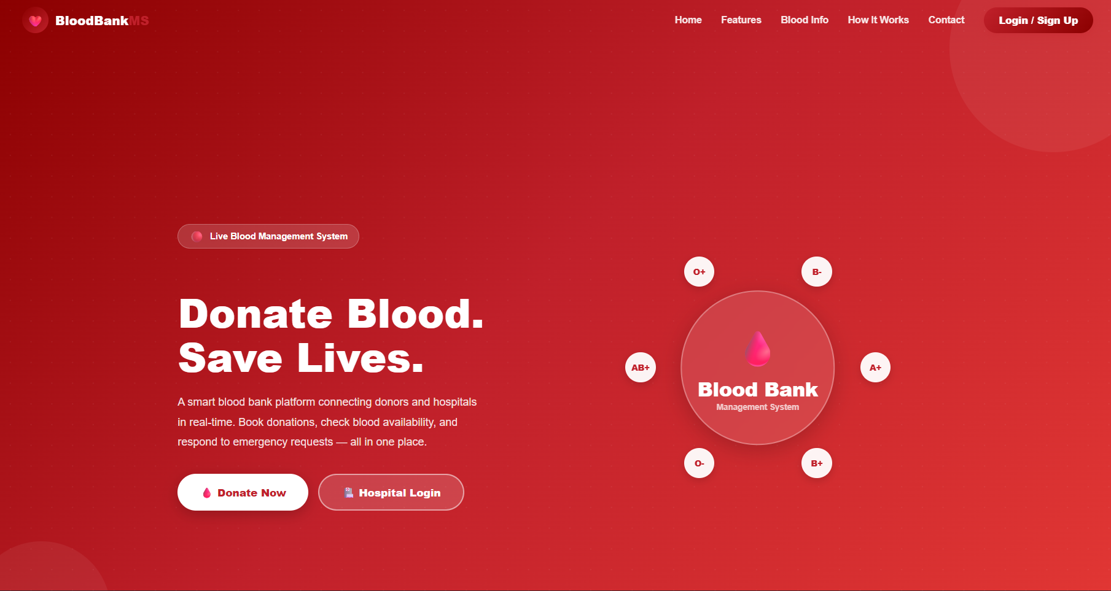
Login page:
i)Donar: ii)Hospital

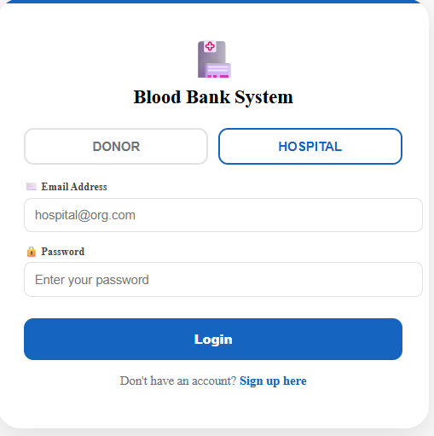
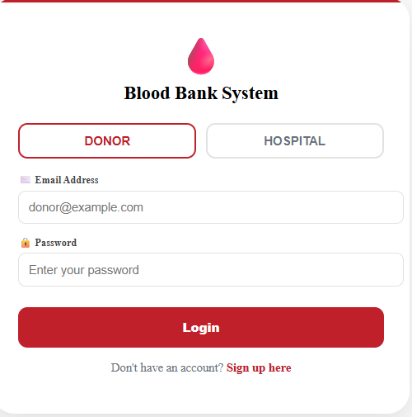
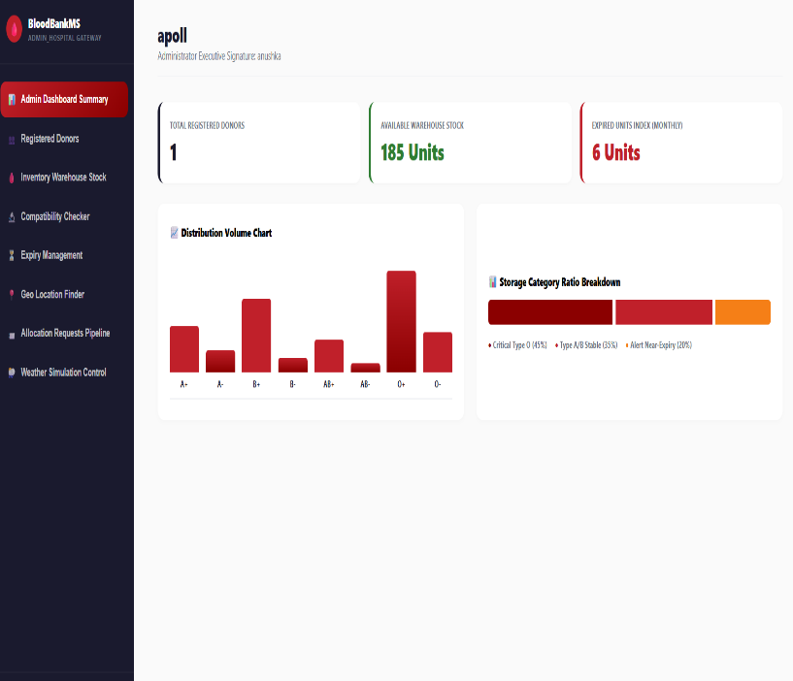
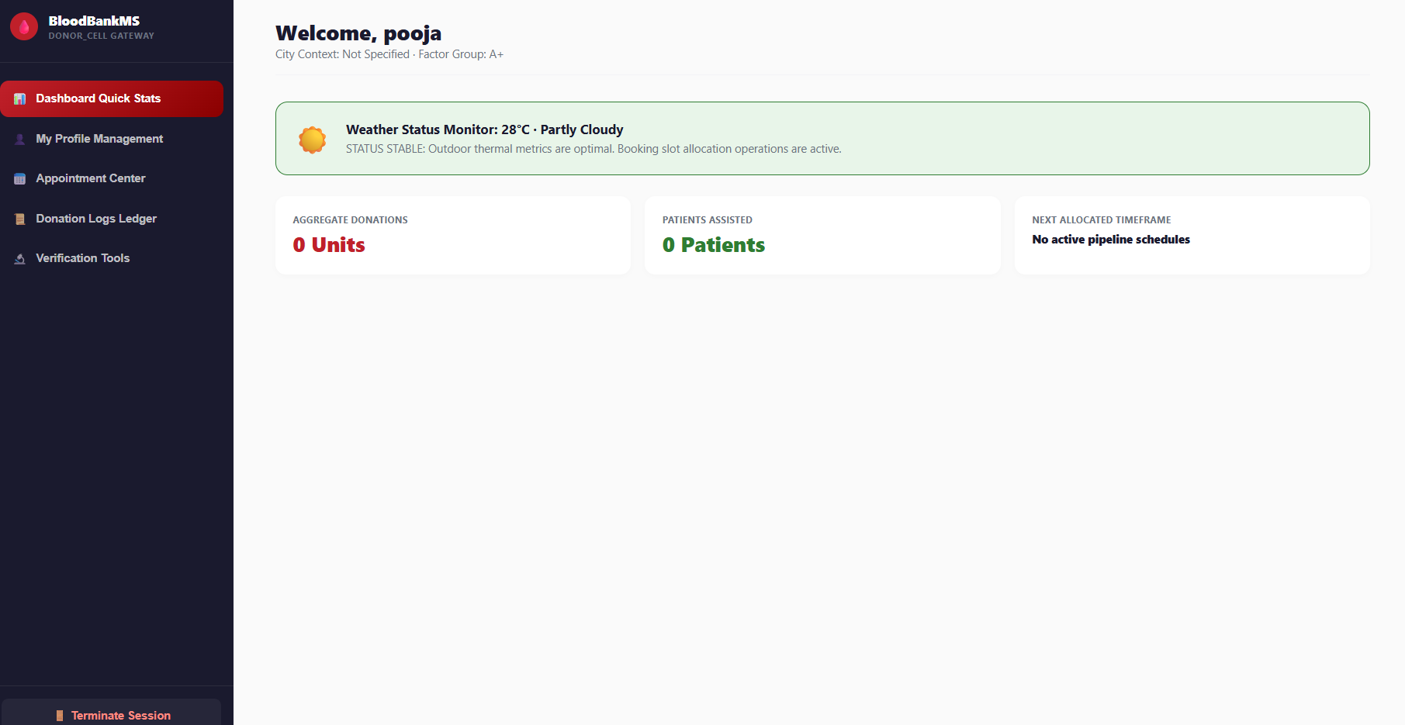

Sample code snippets
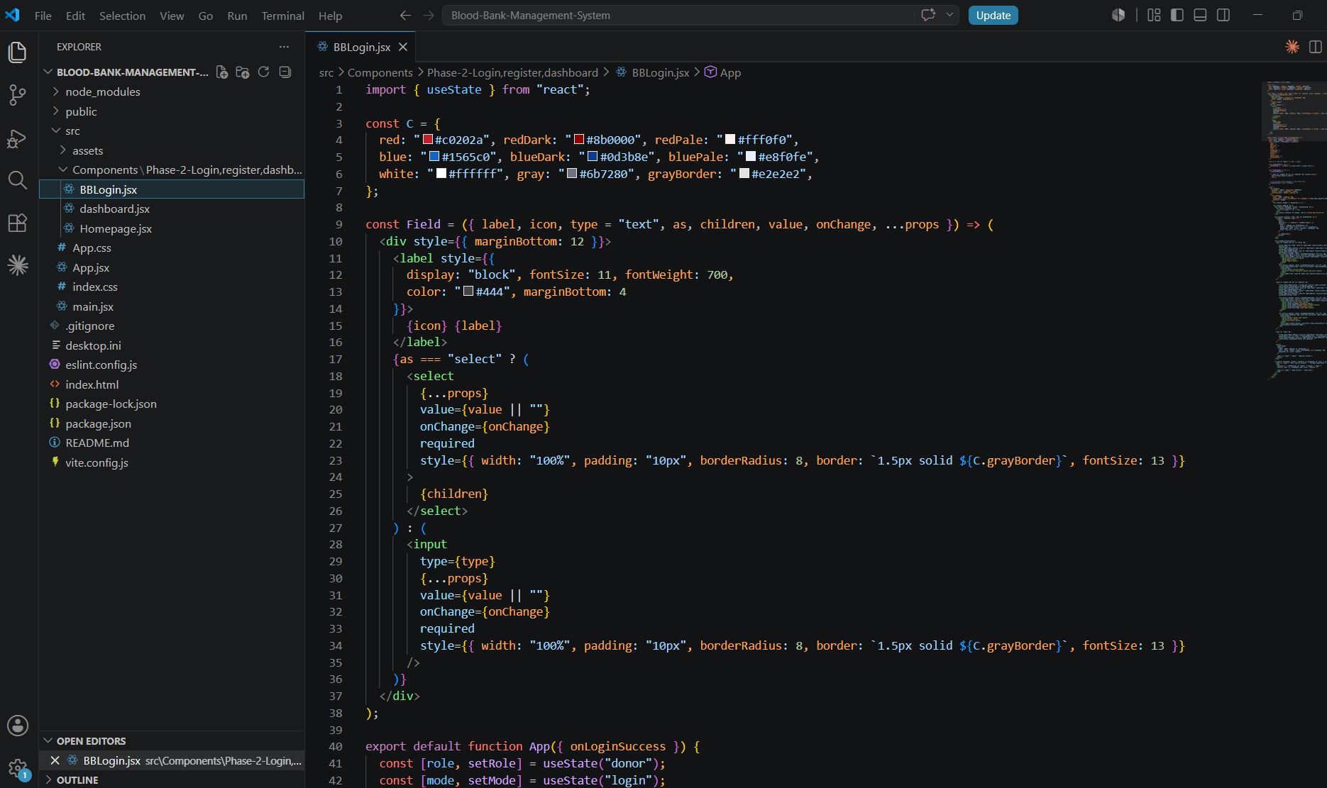

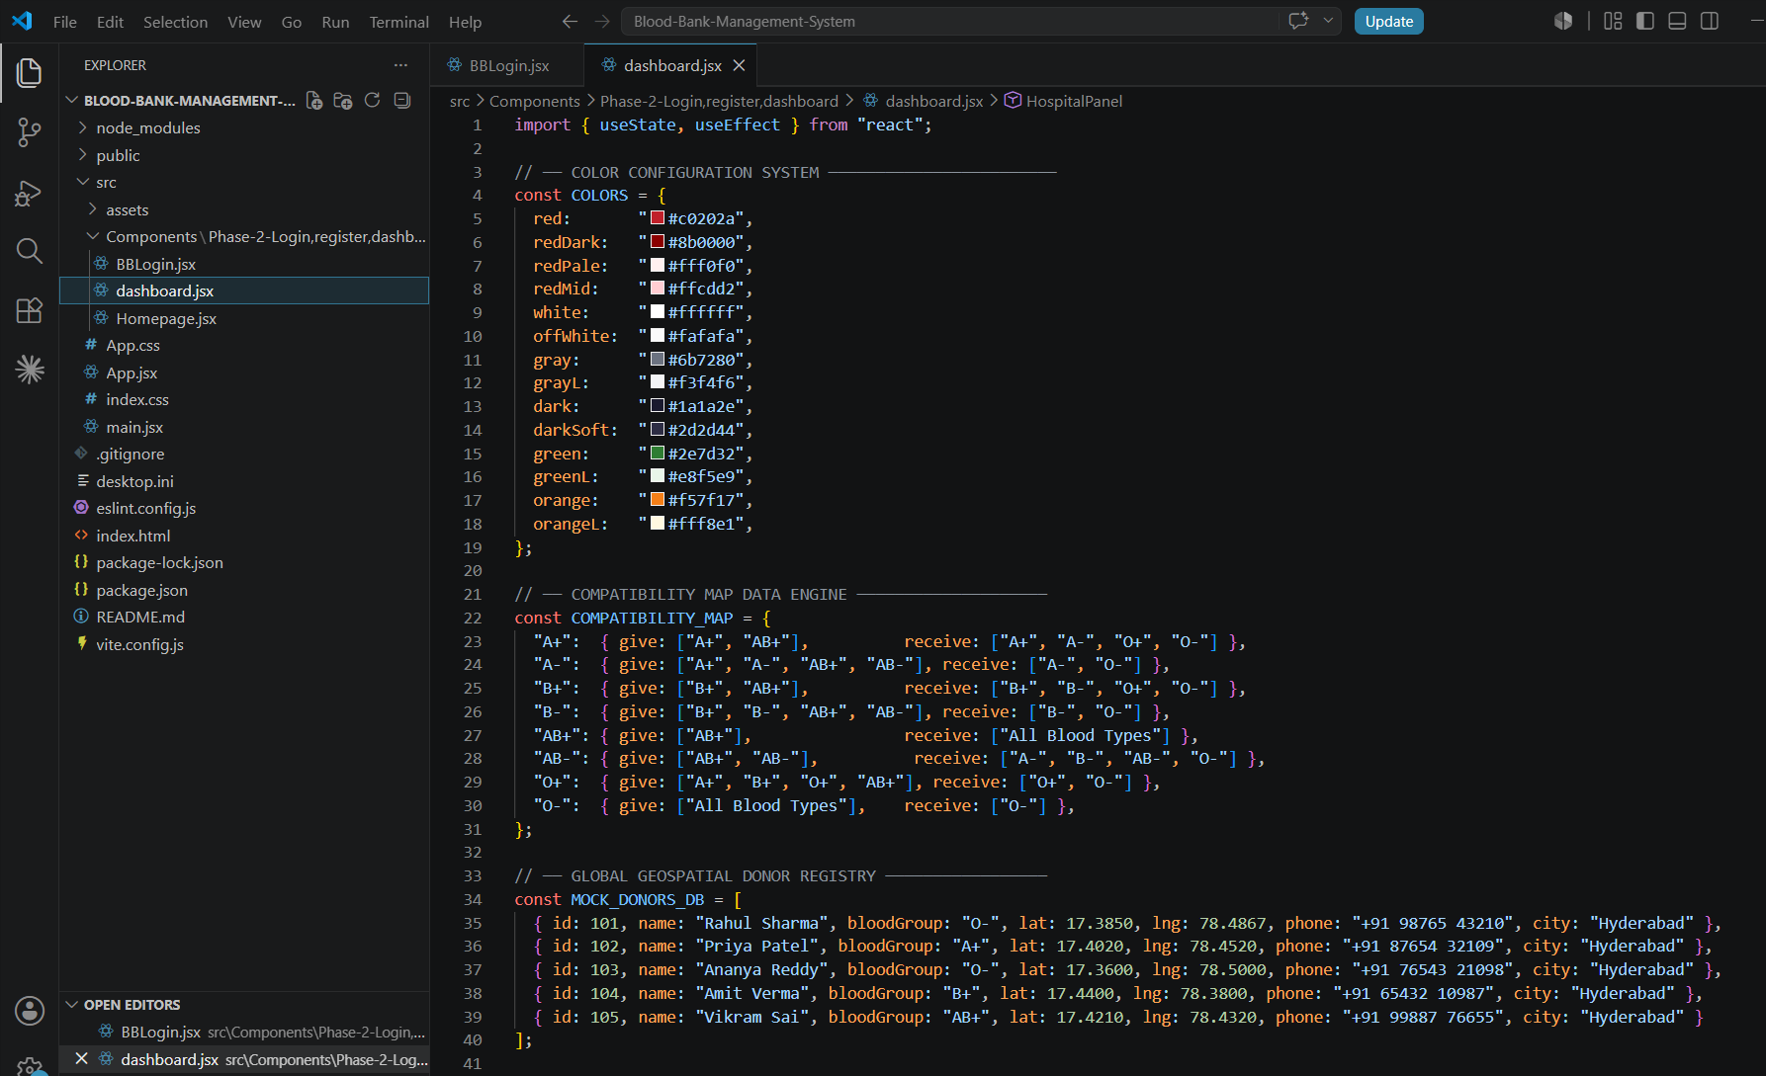

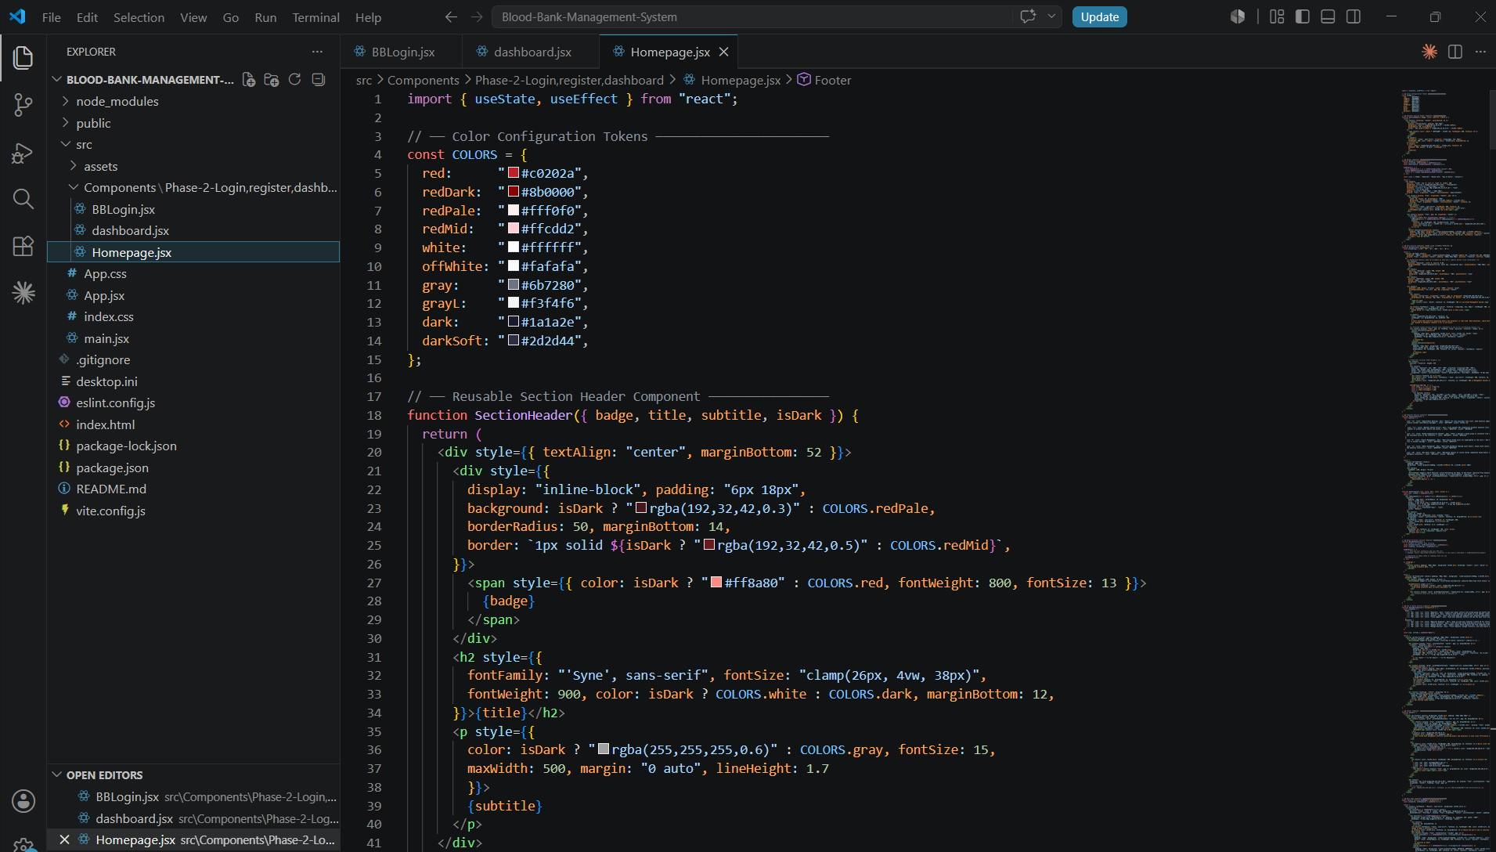

Installation/setup instructions
- Install Node.js and npm on the system.
- Install Visual Studio Code or any preferred code editor.
- Open the project folder using Visual Studio Code.
- Open the integrated terminal in the project directory.
- Install all required project dependencies by running the npm install command.
- After the installation is complete, start the application using the npm start command or npm run dev, depending on the project configuration.
- The React development server will launch, and the application will open in the default web browser.
- Since the application uses Local Storage, no backend server or database configuration is required.
- All donor details, blood inventory, appointment information, and user data are stored locally in the browser using Local Storage.
- The application is ready to use after successful execution and can be accessed through the local development URL provided by the React server.
- The system works efficiently on modern web browsers such as Google Chrome, Microsoft Edge, and Mozilla Firefox and provides a responsive user interface across different devices.

Geo Tag photos with guide



Review forms with guide signatures



B-Tech – Freshman Engineering Department
Rubrics and Evaluation Form
(A.Y 2025-26 – Trimester III)

Review: Rubrics and Evaluation

Course Code & Title: 25CS1201E – FRONT END DEVELOPMENT FRAMEWORKS AND UI ENGINEERING

Name of the Guide: Dr. Neelima Gogineni

Group No: 19 | Roll No. | Name | Phone No.
 | 2520030501 | Anushka Kulkarni | 7093619277
 | 2520030103 | Poojitha Sai | 8712192296

Review Comments from Guide or panel Members:

